|  |  |  |
| --- | --- | --- |
| شعار جامعة بنها الجديدbf |  |  |
| **Benha University** |  | **Faculty of Computers &**  **Artificial intelligence** |

**“ Project Code: CS2021A07 ”**

Diagnosis System for COVID-19  
(with Chest x-rays and medical tests)

A senior project submitted in partial fulfillment of the requirements for the degree of Bachelor of Computers and Artificial intelligence.

**Computer Science Department,**

***Project Team***

1. Anas Rafat Mansour Mohamed
2. Youssef Ashraf Salah Mahmoud
3. Sara Habib Samir Elhabyan
4. Omnia Alwi Abbas Elsayed
5. Islam Elsayed Abdelwahab
6. Ahmed Nabil Mahmoud

***Under Supervision of***

**Dr. Mohamed Taha**

Benha, July 2021

DECLARATION

We hereby certify that this material, which we now submit for assessment on the program of study leading to the award of Bachelor of Computers and Artificial intelligence in Computer Science is entirely our own work, that we have exercised reasonable care to ensure that the work is original, and does not to the best of our knowledge breach any law of copyright, and has not been taken from the work of others save and to the extent that such work has been cited and acknowledged within the text of our work.

**Signed:** _____________________________

_____________________________

_____________________________

_____________________________

_____________________________

_____________________________

**Date:** July 14th, 2021

ABSTRACT

The integration of disease prevention and protection programs is one of the most important programs in the world, as it aims to protect the general public from diseases and epidemics.

As we know recently, some serious diseases have spread, the most important of which is the emerging corona virus, which is considered a category of diseases that attack the respiratory system. The number of confirmed deaths due to the Corona virus epidemic around the world has exceeded 3 million, according to the statistics of John Hopkins University,USA.

This comes at a time when the Director of the World Health Organization announced that the world is "close to reaching the highest rate of infection with the virus ever" recorded.

In our project, we are trying to provide protection to citizens from the emerging corona virus by reducing mixing between people, supporting communication on the Internet, and providing an opportunity for all citizens to ensure that they are infected with the virus through some requirements from the patient.

# Contents

Contents 4

List of Tables & figures **Error! Bookmark not defined.**

1 INTRODUCTION 6

1.1 Definition: 6

1.1 Problem statement 8

1.2 Motivation: 8

1.3 Scope: 8

1.4 Deliverables 9

1.5 Impact of the project 9

1.5.1 Expected impact on community: 10

1.5.2 Expected impact on market: 10

1.5.3 Expected impact on end user: 10

1.6 Organization of the Project Report 11

BACKGROUND STUDY/ SURVEY 12

ANALYSIS 14

System users 15

List and categorization of system stakeholders, 15

System Requirements List: 16

NON-FUNCTIONAL requirements 16

SYSTEM DESIGN 22

High level system architecture: 22

platform context diagram: 23

Data Flow Diagram Level(0,1): 23

Data flow diagram processes 24

flow chart of users interactions with the platform 25

DEVELOPMENT 26

software platforms: 26

software development tools, languages 26

development of machine learning models 26

Frontend Implementation 68

PROBLEMS & SOLUTIONS 72

CONCLUSION 73

FUTURE WORK 74

References 75

List of figures and tables

Figure ‎1‑1: virus infection rate 7

Table ‎3‑1: platform users. 14

Table ‎3‑2: system users. 15

Figure ‎3‑3: Time line 1. 19

Figure ‎3‑4: Time line 2. 20

Figure ‎3‑5: Team Structure. 21

Figure ‎4‑1:System Architecture. 22

Figure ‎4‑2:Context Diagram 23  
Figure ‎4‑3:Data Flow Diagram 24  
Table ‎4‑4:DFD proceses 25

Figure 6‑1:Machine,Deep Learning 27  
Figure ‎6‑2:Model Classification 30

Figure ‎6‑3:X-Rays Classification 31

Figure ‎6‑4 Desktop Implemwntation 72

Table ‎7‑1:Problems & Solutions 73

*Chapter 1*

# INTRODUCTION

## Definition:

Most people nowadays want their lives to go faster and get results by paying less money and less waiting time. When creating any medical system we need to know some patient information and ML algorithms to make the system automatic control, this is easier in the system as a whole but if We wanted to create a platform, there are many problems that we face, in real life we need to go to laboratories and hospitals to perform analyzes and make sure of our health, but after using medical programs we will save effort and money and the results will be in a good and satisfactory manner for the patient and also protect him from any disease.

**Why do we care about Diagnosis System?**

Providing some time for patients, saving effort and money, and also preventing them from mixing with each other and giving them the opportunity to ensure their health without contracting any disease or virus because one of the most important factors in preventing the spread of diseases is prevention and not mixing between people. We care about these programs to make the lives of citizens safe, easier and faster than before.

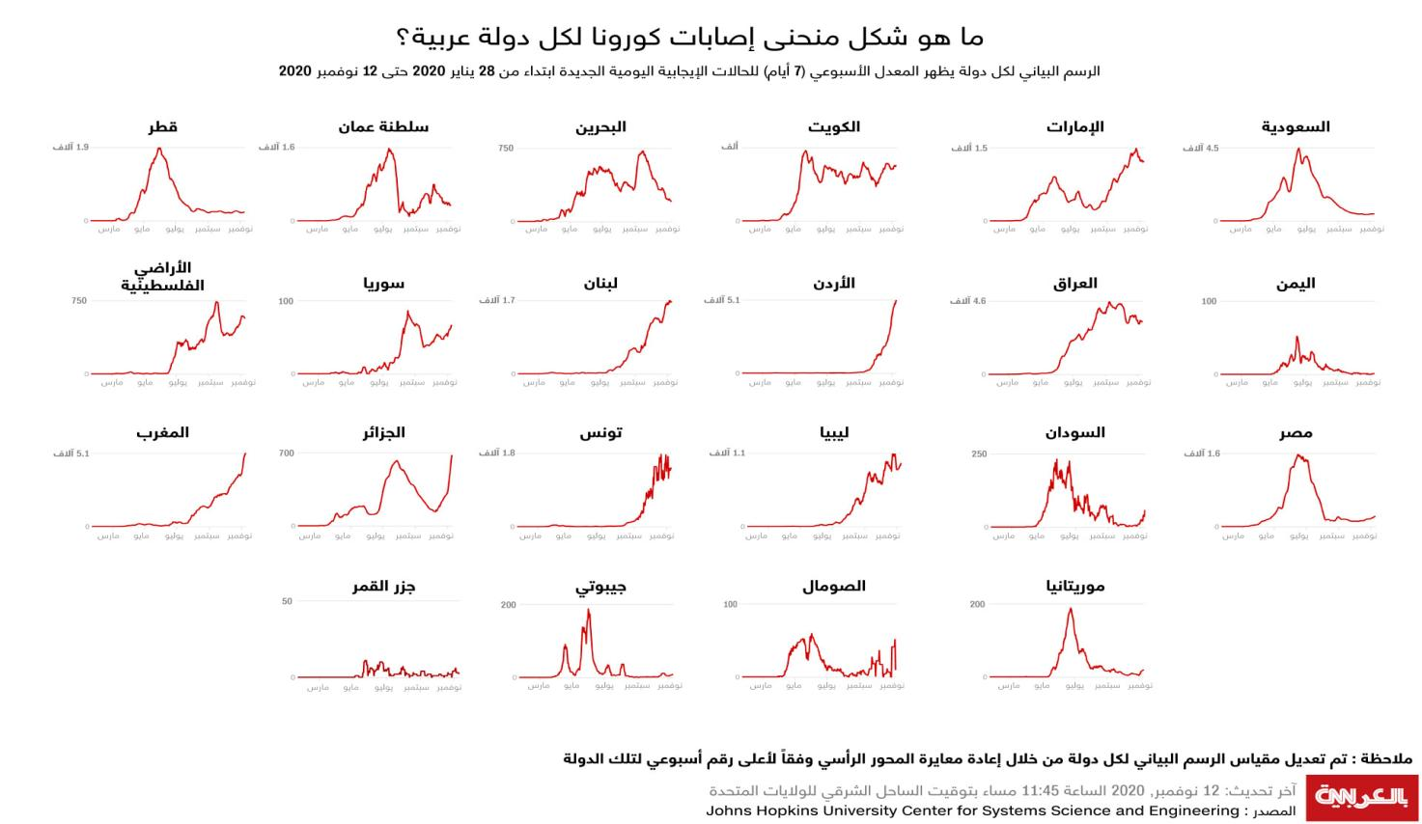This plot show how number of Virus infection rate over time :

Figure 1‑1 Virus infection rate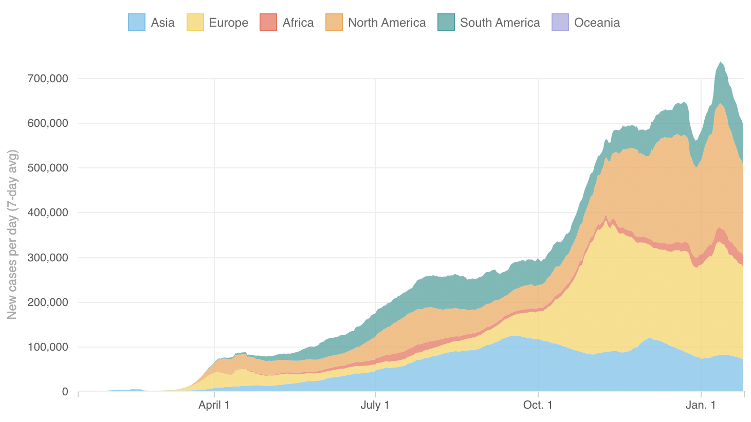

Source:  Case data from the [Center for Systems Science and Engineering at Johns Hopkins University](https://github.com/CSSEGISandData/COVID-19).

## Problem statement

The goal of the project is to facilitate its implementation for people who need to confirm their infection with the virus and know the path of prevention and the required analyzes to know the possibility of contracting the disease.

## Motivation:

* Given the country's spread of the new Corona virus epidemic, for this reason we have to create a technology that contributes to solving the crisis of the spread and increase in the number of Corona and protect citizens from crowded places.
* Spreading medical awareness among people from a distance through contact between the patient and the doctor in an indirect way through an integrated medical program and saving effort and money in an easy way that allows the average user to deal with the program without feeling any complexity or difficulty.
* Another aspect of our platform it also targets developers who need a cheap and easy solution to test and deploy their work.

## Scope:

The main objective of this project is to create a file for the patient within the program and to know the percentages of the required analyzes and to know the x-rays, and all these requirements are sent to the database to be processed and then send the result to the patient

## Deliverables

- SW devices:

1. A fully functional android application that enables users to enter data for the patient and the duration of infection with the virus.
2. Create a desktop application to collect and process data.
3. Making a standard integration technology that fits any medical system.
4. A machine learning model for classifying cases of infection with the Corona virus.
5. Deep learning model for chest x-ray identification.
6. Building a database on firebase to receive, store and send after processing data from different platforms.
7. A logical control system in the system to send data to the patient after processing it.
8. Establishing a reinforcement learning factor to train the program to know the disease within Analytics tests and rays.
9. Create a text recognition form to extract text from images using firebase.
10. Create a continuous learning approach to update my ML models based on new data.

## Impact of the project

We expect that our solution will have a great social impact because it will enable any user to know the status of his infection with the virus, protect patients from mixing and reduce the possibility of an increase in people infected with the virus. Send a protocol with the required instructions in case of infection with the virus or in the event of suspicion.

### 1.5.1 Expected impact on community:

Our project will accelerate our travel towards a digital and smart world, as it enhances and simplifies the concept of medical programs for ordinary users by enabling them to fulfill their request for the program and know their health status.

### 1.5.2 Expected impact on market:

The market is expected to be much open to new and innovative ideas as users will be increased and new system developers will enhance our system by opening the way for new investments in this field that make our world a better place.

### 1.5.3 Expected impact on end user:

Facilitating the use of the program for the user to know his illness condition and to ensure that he is infected with the virus by reducing his mixing with people, protecting him and saving his time

## Organization of the Project Report

In This report we will discuss how the complexity of integration is a serious problem in diagnosis system and how our solution solved it in a revolutionary and simple manner.Chapter 1 present’s brief introduction about the project, problem statement, scope, deliverables and impact**, Chapter** 2 presents Background Study/Literature Survey, and Chapter 3 presents the Analysis of the project. WhileChapter 4 presents the design of the project. Chapter 5 presents the development steps as we -the development team- went through them. And Chapter 6 presents Backend implementation of our proposed system while Chapter 7 presents frontend implementation.

Chapter 8 presents the problems & solutions, followed by Chapter 9 which presents conclusion and finally, chapter 10 which presents the future work.

*Chapter 2*

# BACKGROUND STUDY/ SURVEY

First, we read the research on remote medical diagnostic programs to know the latest updates in this field, then we tried to use the existing electronic platforms for the leading companies in this field. We noticed that there are not many medical diagnostic programs for the Corona virus, because quite simply, the simplest way to identify the infection was to make a smear medical examination for the Corona virus, but the medical smear for the Corona virus is held in laboratories, and those laboratories have many infected people, and thus the mixing between people increases, and thus the rates of infection with the disease increase.

In addition, the price of the swab is not within the reach of all the injured, and that swab is done more than once because the patient may not be infected today, but tomorrow he will be infected.

* Brainstorming sessions with team members and the project supervisor
* Surveys of students and doctors in our college asking them about our system and how to improve it
* Meetings with doctors in the Faculty of Medicine and Engineering at our university to ask them about the basics of virus prevention and how to identify it and the stages of developing medical programs, and interviews with doctors of the respiratory department to obtain the requirements that the project needs to diagnose the patient in a correct way and give him a protocol or a medical report according to the patient's condition.
* Communicate with physicians at the College of Medicine and ask how our medical system can assist them in the process of diagnosing disease.
* Read the papers related to the idea of ​​our project and its applicability in a real project
* Conducting a survey about the machine learning models that should be present in every system.

*Chapter 3*

# ANALYSIS

To ensure our platform availability and ease of use, we have defined a connectivity standard that can actually work with the desktop software of our data processor and engines supported by our platform by following well-defined steps that appear in the mobile application Provide the platform with trained machine learning models that users can easily deploy in Their systems With just a few clicks in the application, we have studied the expected risks that may face us during the development of the

* Project and provide contingency plans for each expected risk.

|  |  |  |
| --- | --- | --- |
| Anticipated risks |  | Contingency plan |
| Inaccurate output of any ML model in our platform | $$→$$ | Try different data set and different algorithms to implement these models |
| Delay in getting response from ML models | $$→$$ | Try different methods that guarantee real time communication and try to optimize the response time of the ML model |
| The platform is hacked | $$→$$ | We creating daily backup files of all database and also backup of all scripts on servers, so we can get the platform back to it is full functionality in a minutes. |

Table 3-1 platform users

## System users

|  |  |
| --- | --- |
| User Type | Description |
| Patients | 1. A patient with common symptoms of the emerging coronavirus (Covid-19). 2. He wants to make sure that his belief is correct or not, and consult a doctor about the ideal method of treatment. |
| Doctors | 1- Doctors who have private clinics and wish to own an electronic system that helps them organize the examination times for patients to provide sufficient time for confirmed cases of corona.  2- Doctors can use our platform to implement a medical shield powered by Ai to help doctors diagnose patients accurately, with fewer and limited errors, to protect patients, and increase prevention methods and distance between people. |

Table ‎0‑1: platform users

## List and categorization of system stakeholders,

Our platform contains several application scenarios that may lead to marketing activities beyond this project. For example:

O Ministry of Health and Population

O Medical centers and private and public hospitals.

## System Requirements List:

**FUNCTIONAL REQUIREMENTS:**

The illustrated use case diagram [3] illustrates the functional requirements, processes, and activities of the patient and the doctor. The first step for the patient is to enter the Android program, write the data and symptoms of the disease, enter the necessary analyzes, an x-ray image, and send all the data to the database to be processed by artificial intelligence, machine language and prediction. The possible result of the patient is recorded on the database, and the data and results for each patient are sent to the desktop program. The second step is to enter the doctor to see the results of the patients and give the necessary report for this case and resend the report to the patient.

## NON-FUNCTIONAL requirements

• **Communication**: The application that is connected to the Internet through mobile data or Wi-Fi, connects to the database through firebase, which is the link between the Android program and the desktop program.

• **System Accuracy**: the reading of data should be correct, transmitted without any change and ML models should accurate and give trusted results.

• **Performance**: for medical system communication must be real time

**• Operational:** This platform work automatically and it is connected to mobile application so user must download the application on their mobile to control deploy and use their systems.

**• Cost:** the cost of this system must not too expensive because we only sell software service.

* **Challenges encountered [and lessons learned] during the requirements gathering, analysis phases:**

There are many lessons learned and challenges in phases of system’s requirements:

* Do a brainstorming session and think as a team.
* Improve team members' communication skills.
* Learn how to write formal emails to government agencies requesting information and data sets.
* We learned how to explain our project in layman terms to our potential users.
* Professionalism and formality when communicating with doctors.
* Challenges:
* It was difficult to access a database of patients with a history of corona virus due to government procedures.
* She arranges a meeting with doctors because of their busy schedules.
* Brainstorming sessions are time consuming.
* Brainstorming sessions did not take place at times because some members of the work team were infected with the virus.
* **Detailed schedule and milestones:**
* Milestone 1: Getting started

Making research papers and extensive readings related to our idea, studying educational programs, and compiling databases for the project.

* Milestone 2: designing the basics of models (ML + android + Desktop App).

By the end of this achievement, the initial design of the Desktop App and the mobile program and the design of the image processing and medical analysis model.

* Milestone 3: the method of implementing the integration method

Now we are done (3) We have implemented the models design (device drivers + ML + android) and then we applied our integration technology and tested it on the image and analysis model and implemented the Desktop App design using QT and the implementation of the mobile application using Android It works perfectly at this point, we completed 70% project.

* Milestone 4: linking programs to databases (firebase + Desktop App + ML + android)

The connection between Android and Firebase was done through a communication channel between Firebase and a learning machine to take a feature for each patient and send the output back to Firebase, and a communication channel was made between Firebase and the Desktop Application to take data and send a report back to each patient in Firebase.

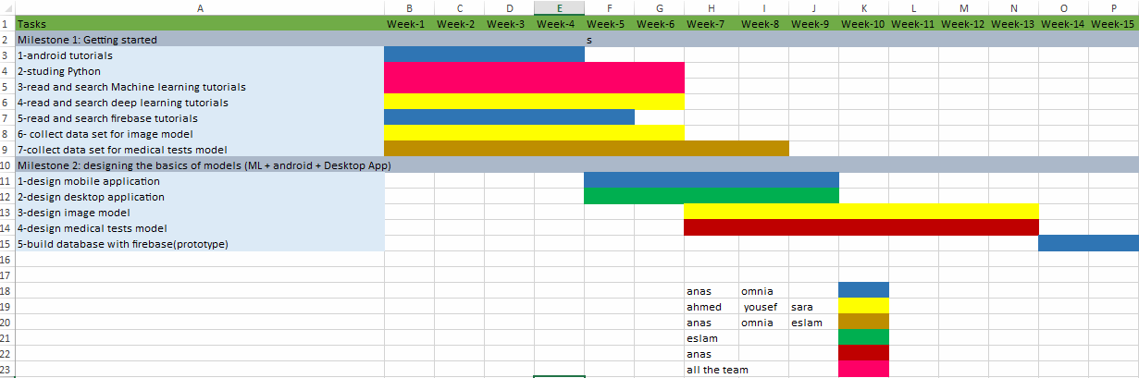  
**Semester 1 Timeline**

Figure 3‑3 Time line 1:

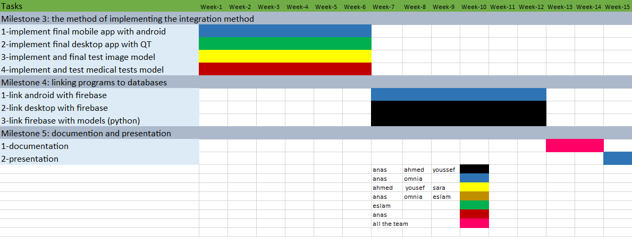**Semester 2 Timeline**

Figure 3‑4 Time line 2:

**Team structure and detailed roles/**

*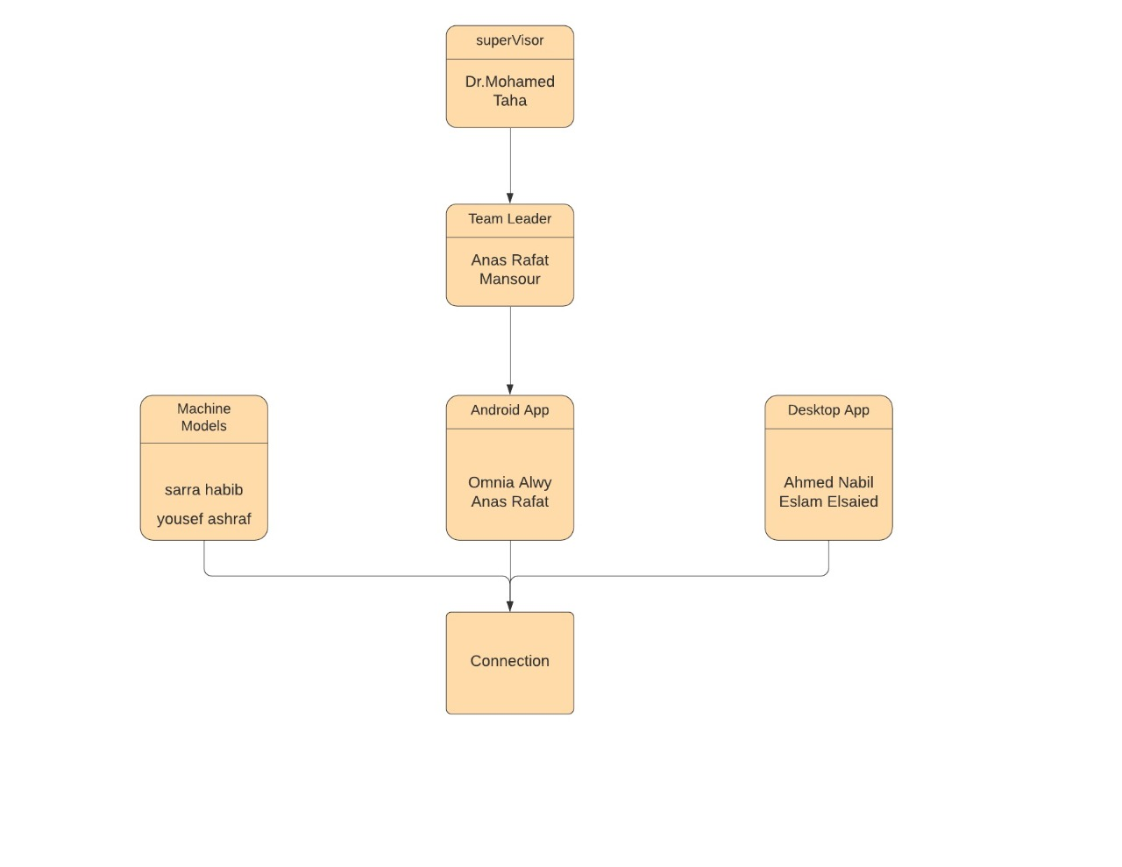***Responsibilities of each member.**

Figure 3‑5 Team Structure

*Chapter 4*

# SYSTEM DESIGN

## High level system architecture:

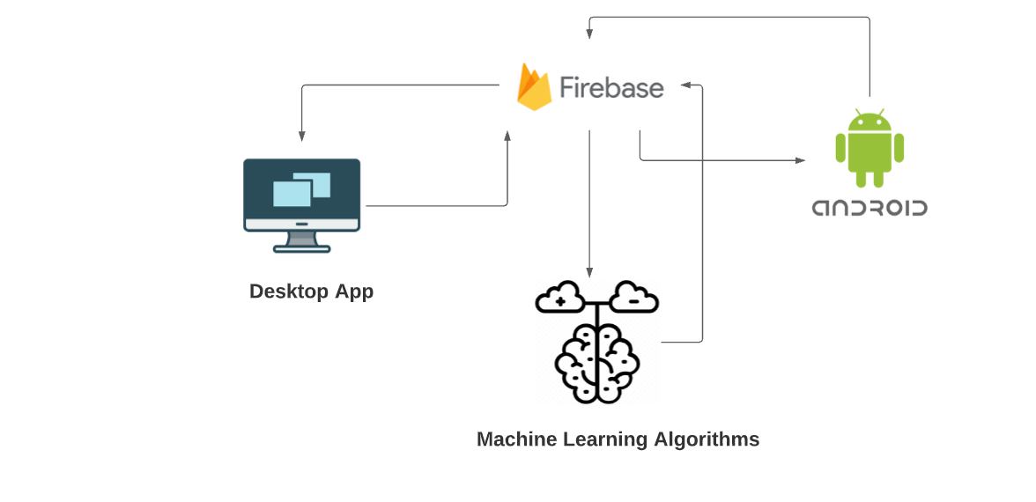

Figure 4‑1 system architecture

This high level system architecture depicts the general system interactions between different components and sources of the platform.

## platform context diagram:

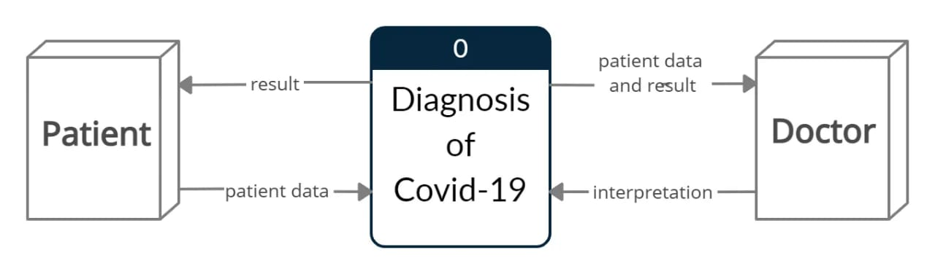

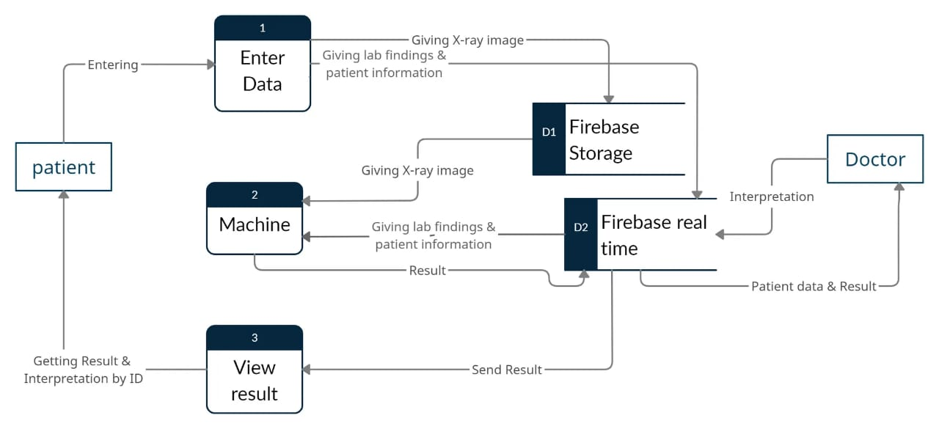Figure 4‑2 Context Diagram

Figure 4‑3 Data Flow Diagram LEVEL (0):

## Data flow diagram processes

|  |  |  |
| --- | --- | --- |
| P# | Process name | Process Description |
| 1 | Enter data | Storing patient personal information and laboratory findings in firebase real time and store chest x-rays in firebase storage. |
| 2 | Machine | Receive laboratory findings, chest x-rays and send results of machine learning to firebase real time. |
| 3 | View result | Doctor send from application to firebase real time the interpretation and the result of The patient's condition. |

Table 4-4 ‎4‑1 DFD processes

## flow chart of users interactions with the platform

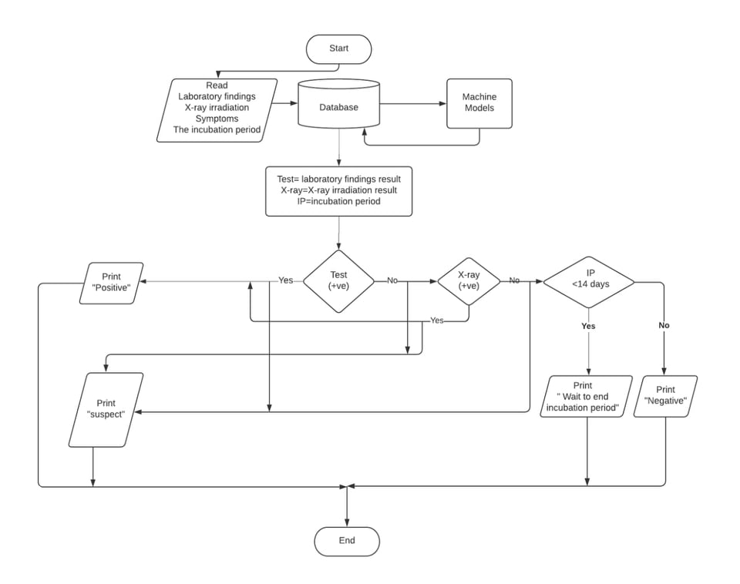

Figure 4‑5 flowchart diagram

*Chapter 5*

# DEVELOPMENT

Beginning the development phase was not very hard. We just had to follow our Gant-chart ,

first let us state hardware ,software platforms that we used .

## software platforms:

**Software Platforms :**

• **Android studio :** is the official integrated development environment for Google's Android operating system we used it to create the android app that connects users to our platform .

• **Anaconda :** is a free and open-source distribution of the Python and R programming languages for scientific computing , we used it to write python code and build our machine learning models .

• **Floyd hub :** is a zero setup Deep Learning platform for productive data science teams ,we used it to train our models .

• **MQTT :** is a machine-to-machine (M2M)/desktop app .

## software development tools, languages

**Software Tools :**

* **Anaconda Navigator:** It’s the environment that contains libraries and IDE’s Used for developing python code for machine learning algorithms.
* **Python:** Is an interpreted, high-level, general-purpose programming language used for coding the machine learning models and Deep learning models .
* **Java :** Is an interpreted, high-level, general-purpose programming language used for coding Android Application.
* **Jupiter lab:** Is an online interpreted, high-level, general-purpose programming language used for coding image model.

## development of machine and deep learning models

*Chapter 6*

# backend Implementation

* **Working on Image model:**

**Deep Learning:-**

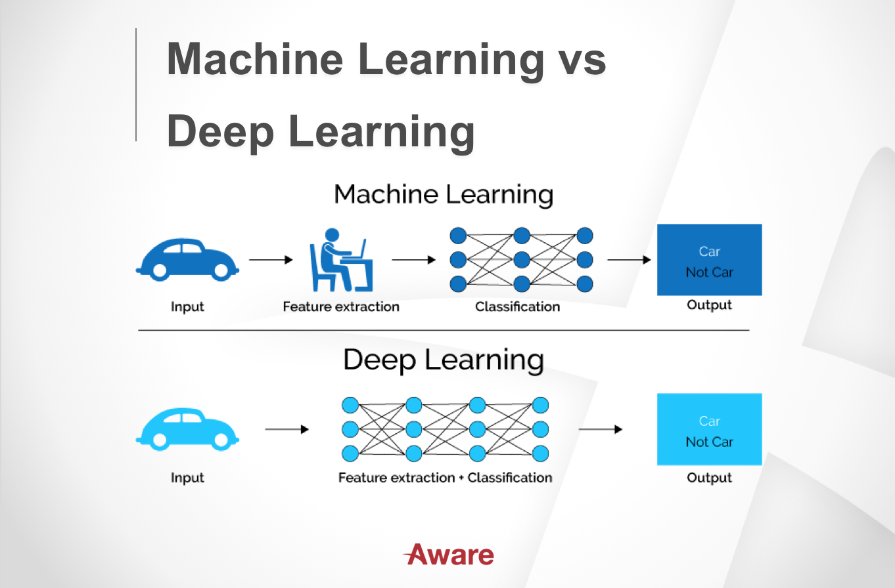

Figure 6-1 machine and deep learning

Machine learning is an application of AI that includes algorithms that parse data, learn from that data, and then apply what they’ve learned to make informed decisions.

Deep learning is a subfield of machine learning that structures algorithms in layers to create an "artificial neural network” that can learn and make intelligent decisions on its own.

**X-Rays covid-19 Model:-**

**First-Dataset:**

Split data into:

Validation data: 30% of all datasets

Training data: 70% of all datasets

**Then-libraries:**

1-Tensorflow:

Performs various tasks, including model optimization, graphical representation, probabilistic reasoning, and statistical analysis.

Tensor flow can do numerous ML tasks but is highly used to build deep neural networks.

2-Keras

Provides a large number of already pre-trained models. It supports recurrent and convolutional networks and the combination of both networks too is famous for its runtime execution speed, parallelization and factorization capabilities. It is useful for matrix data manipulation like reshape, transpose, and fast mathematical/logical operations. Other operations like sorting, selecting, basic linear algebra, discrete Fourier transform and much more.

* Kears built from tensor flow.
* Easier to deal with deep neural than tensor flow.

3-NumPy

Is famous for its runtime execution speed, parallelization and factorization capabilities. It is useful for matrix data manipulation like reshape, transpose, and fast mathematical/logical operations. Other operations like sorting, selecting, basic linear algebra, discrete Fourier transform and much more.

4-Pandas

Enables the user to read/write datasets.

5-Matplotlib

Can be customized to plot charts, axis, figures or publications.

**Then-Model Classification:**

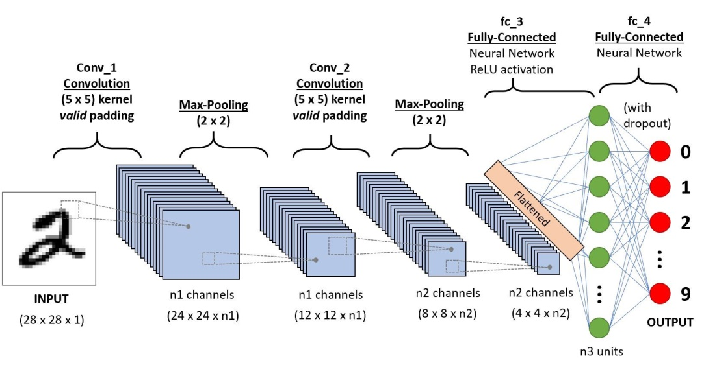

Figure 6-2 Model Classification

**X-Rays classification (deep learning):**

We start getting all the x-rays on the model (model = Sequential ()

We start doing equations on x-rays as filters (and we determine the size of the filter) and as Maxpooling, dropout

Repeat on all layers .activation function differ from input layer than hidden layer, output layer. As well

All operation:

We do training for all the x-rays (training, validation data) so that after that we can determine the efficiency (accuracy) of the model and we will determine it from a part of validation data

Finally detect from test data which x-ray is normal, which is covid-19.

Operations:-

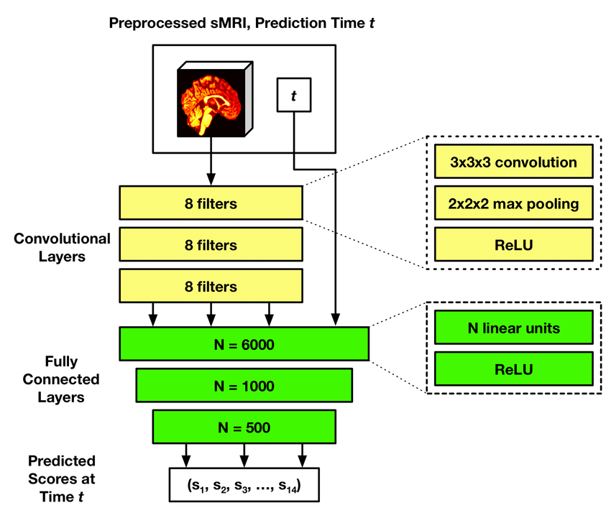

Figure 6-3 X-Rays classification

**Convolution:**

Is a common image processing technique that changes the intensities of a pixel to reflect the intensities of the surrounding pixels? A common use of convolution is to create image filters.

--kernel size. Show image before and after filter

**Max pooling:**

Is a type of operation that is typically added to CNNs following individual convolutional layers?

**Dropout:**

Is a technique that addresses both these issues? It prevents over fitting and provides a way of approximately combining many different neural network architectures

**Dense:** for hidden layer.

**Activation functions:**

The neural network activation functions, in general, are the most significant component of Deep Learning, they are fundamentally used for determining the output of deep learning models, its accuracy, and performance efficiency of the training model that can design or divide a huge scale neural network.

The addition of activation function to neural network executes the non-linear transformation to input and make it capable to solve complex problems such as language translations and image classifications.

----Types: - type differ from layers

Linear, Relu, Sigmoid, Softmax,

* **Desktop Application:**
* We have implemented the design of the desktop application using the qt5 (python language) programming interface designer, which is responsible for helping the doctor access the patients’ data recorded through the Android application and analyze this data to determine the possibility of contracting the disease or not, and it is useful in saving time and keeping him away from mixing with suspected people in contracting the virus.
* Form1:-
* In the beginning, we designed a window that allows the doctor to search among the list of registrants by name, and it appears in the order of the LIFO system, and he can enter patient data by pressing the (View Information) button to enter it on the second window.

Detailed explanation of code:

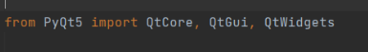We called some libraries to deal with the list of registered patients.

* 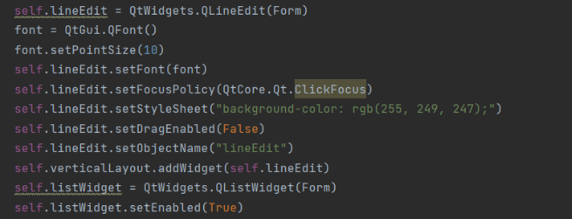We set a search bar (Line Edit) so that the doctor can search for the patient by writing his quadruple name.
* We have developed a list to receive the registered patients from the firebase and show them to the doctor to enable him to choose one of them and access his data.

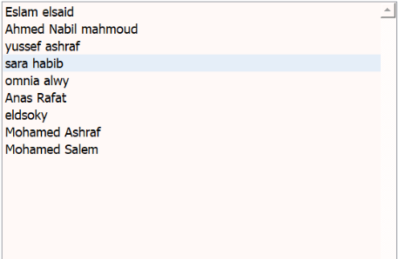

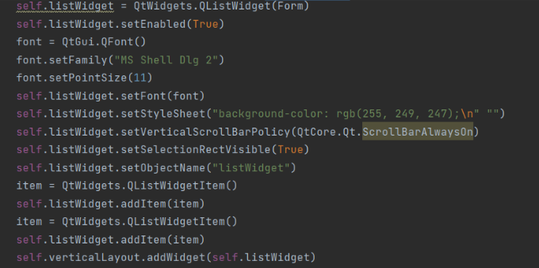

* 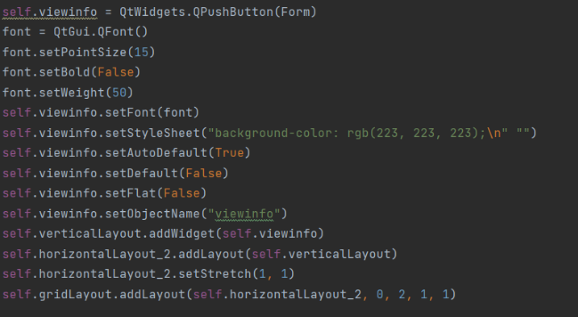When the doctor selects the patient by clicking on the (View Information) button, he is transferred to the patient's data in the second window.
* Form 2:-
* When the doctor search for one of the registered patients & selecting it with clicking on the (Show Information) button, he is transferred to the new window which includes this patient’s personal and medical data and allow the doctor to send tips for prevention of viral infection or may treatment directions in case of the patient is suspected to be infected by covid 19.
* Detailed explanation of code:

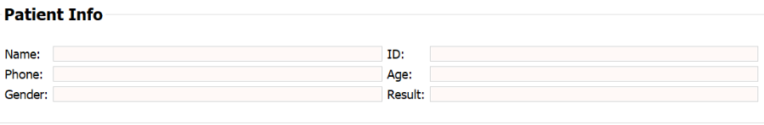In this window firstly, there is a group box that containing the patient's personal data such as name, phone number, age, gender and national number.

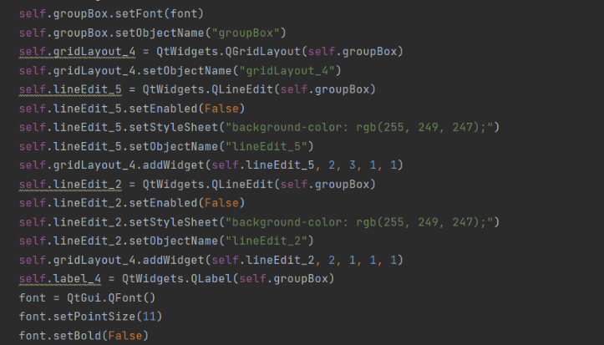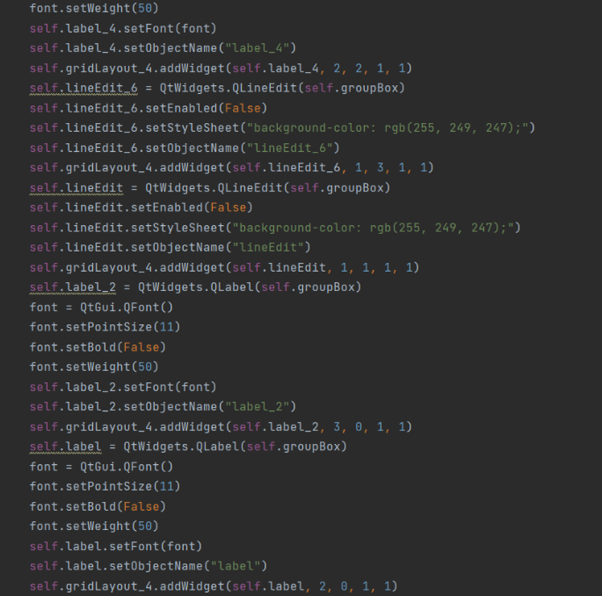

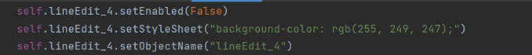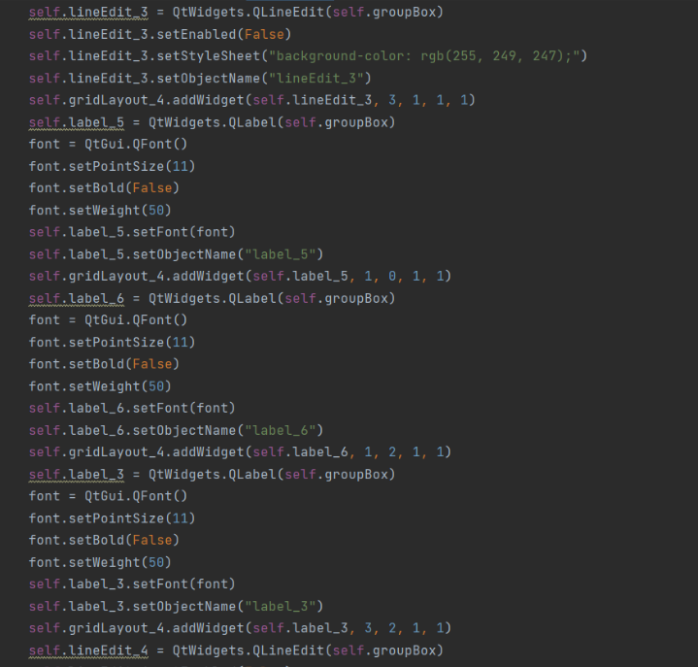

* Then another group box that including the patient's medical data, such as the laboratory findings results and chest x-rays image.

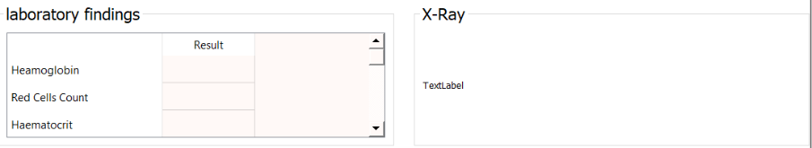

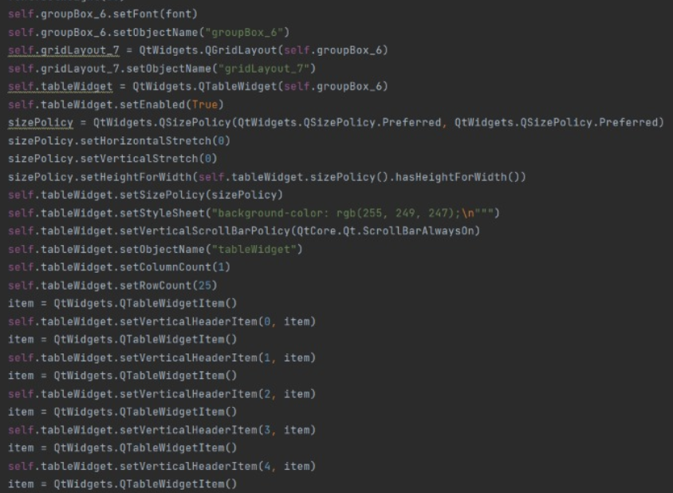

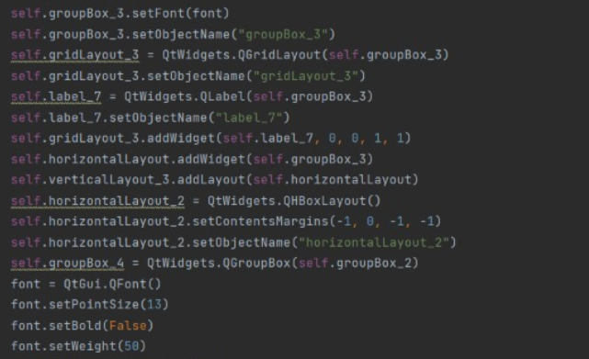

* And finally, the last group box containing most possible symptoms of corona virus that reported by CDC “Centers for disease control and prevention” that the patient may feel in case of infection by covid 19 in addition to the incubation period which is the period till the patient feel the suspected signs and finally there is the doctor’s interpretation about the patient’s current condition.

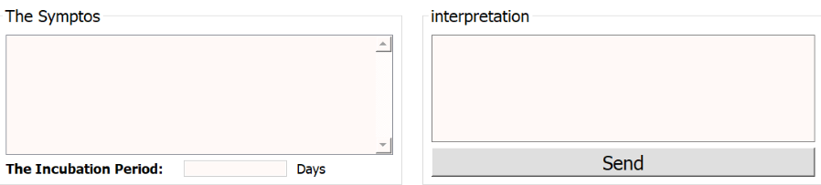

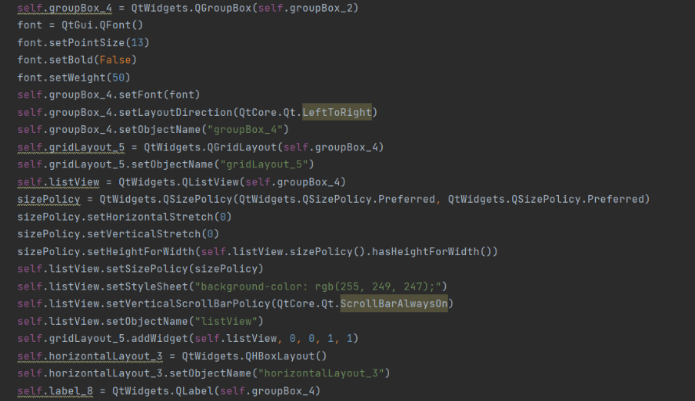

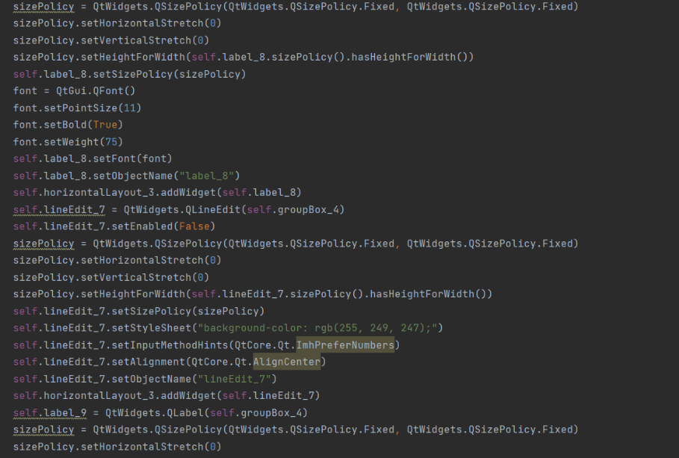

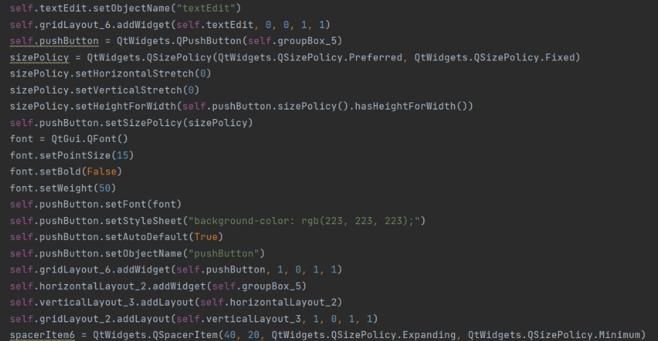

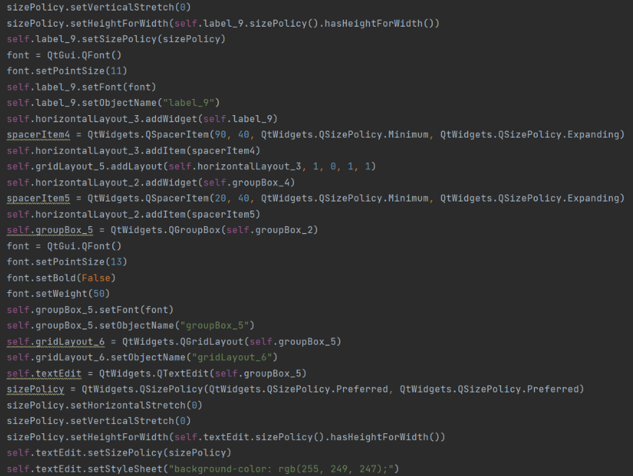

* The back button is responsible for returning to the previous window in the case of searching for another patient.

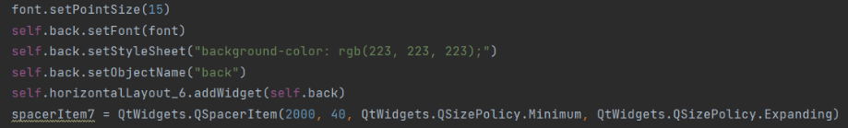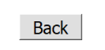

* Whilst the finish button is responsible for completing the search process and sending the doctor's interpretation in case of suspected patients.

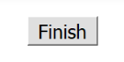

* Form 1 actions:-
* This function helps us to show the first window and its content.

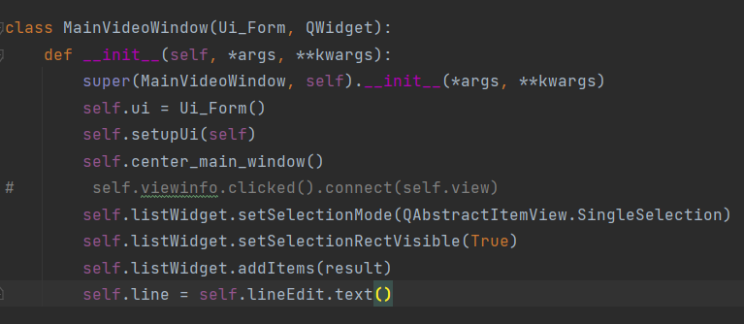

* 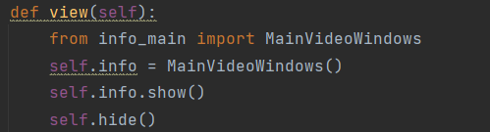When you click on the (View information) button, the current window will be hidden and a window will appear containing the patient data for which the doctor chose his ID.
* Form 2 actions:-
* 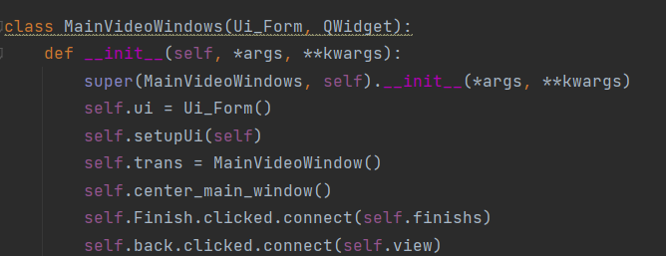This function helps us to show the second window and its content.
* 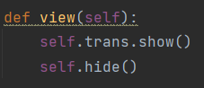In the event that the doctor wants to go back a step, when he clicks on the (back) button, the current window is hidden and the previous window that contains the list of registered patients is shown.
* 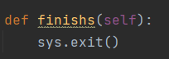When the doctor finishes his search, when he clicks on the (finish) button, the program is exited.

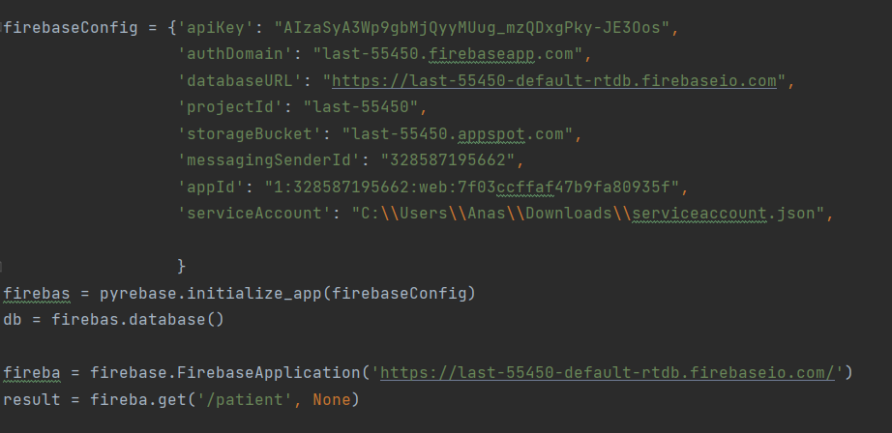Firebase connection code :  
  
  
- When the doctor finishes his search, when he clicks on the (finish) button, the program is exited.  
  
  
  
  
- To Send the patient content in firebase to the list in the first window .

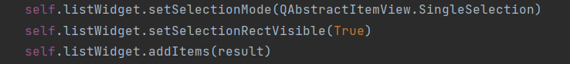

* To get the patient's medical data in Firebase and put it in variables to be used in linking the desktop application and Firebase.

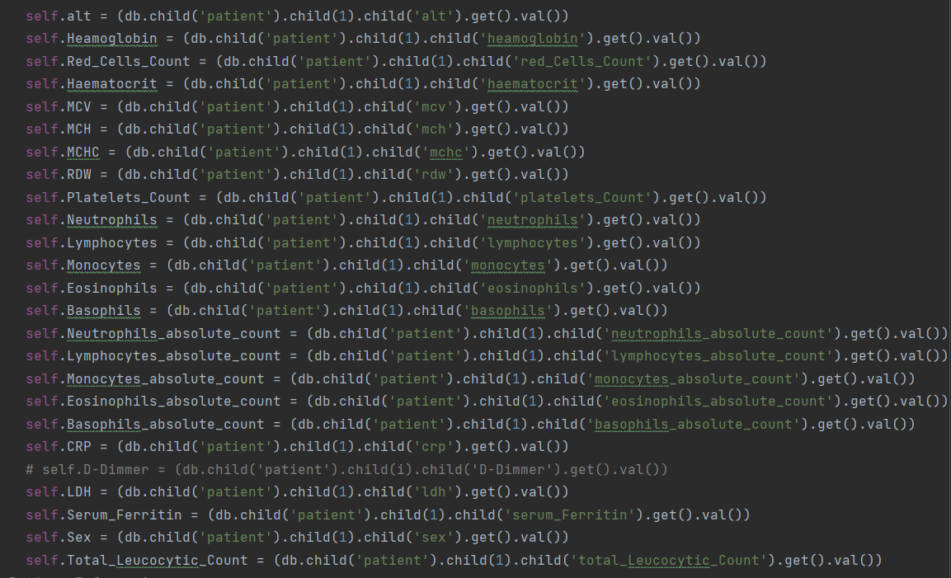  
  
- To get the patient's personal data contained in the firebase and put it in variables to be used in linking the desktop application and the firebase.

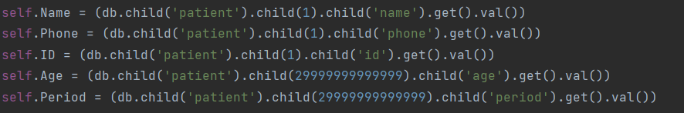

- To get the symptoms that the patient feels registered in Firebase.

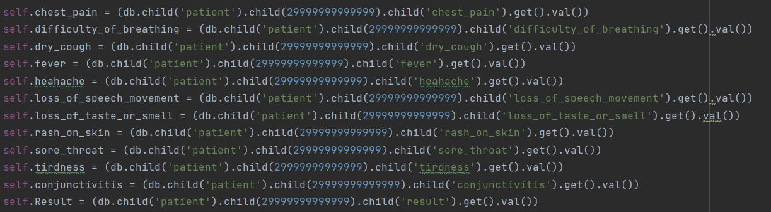  
  
- Linking the contents of the desktop application to the variables in which the data in the Firebase is stored.

* 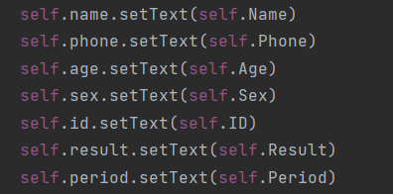First, personal data
* 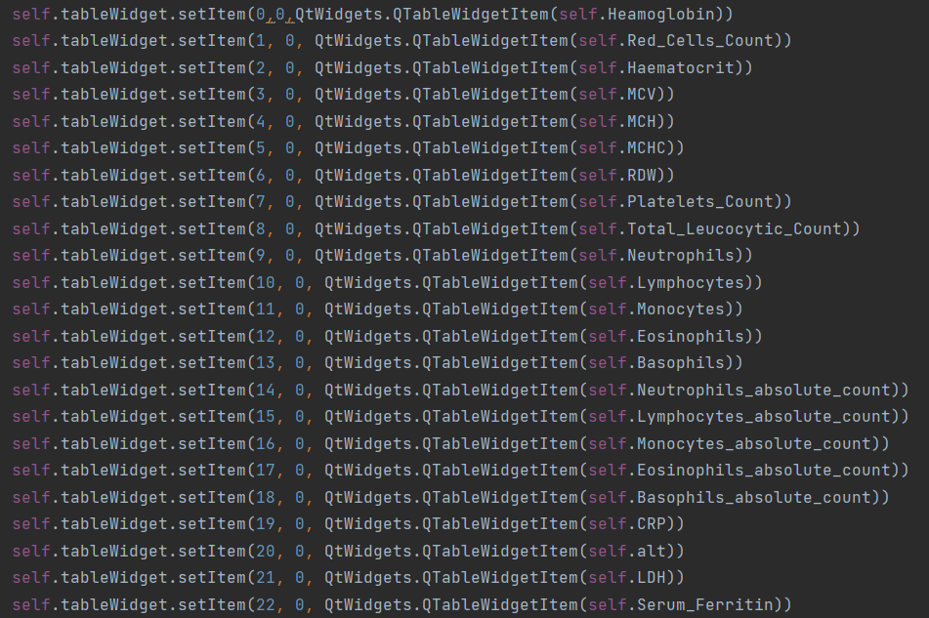Second, medical data
* 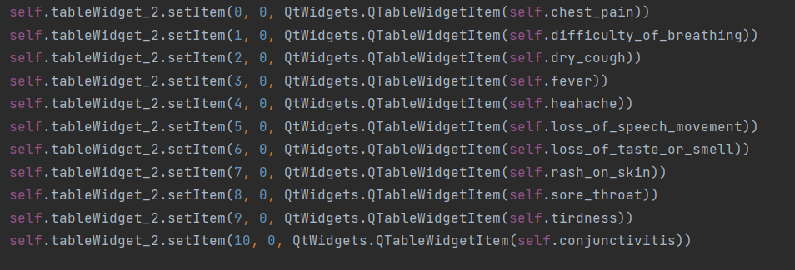Third, symptoms of the disease  
    
    
  **Android Application:**

1. home_activity (Home):

* content:

1. image_view(1)
2. Button(2)

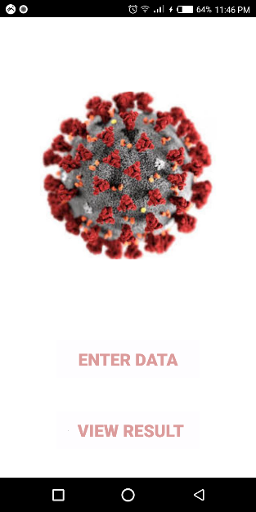

* + image_view _Code_XML:

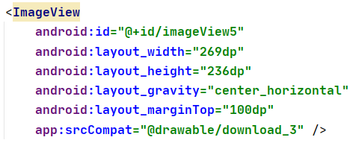

* insert image from @drawable in activity
  + 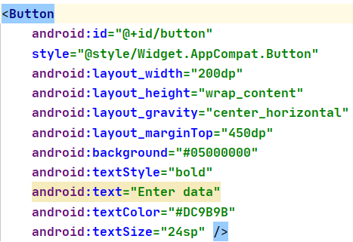Enter Data_Code_XML:
  + Pass priorities of Button :
* 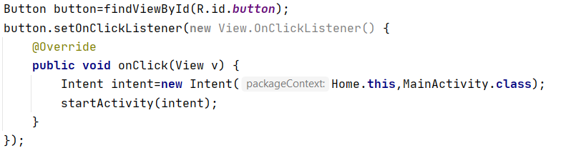Enter_Data_Code_Activity:

* Code of to go from home_activity to activity_main by press on Enter_Data.:
  + View_Result_Code_XML:

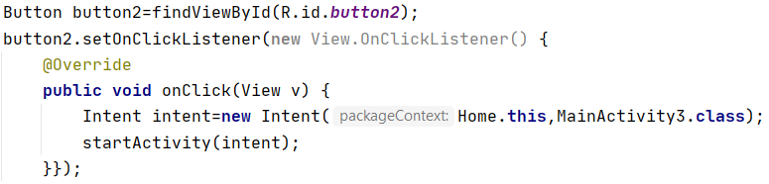

* Code of to go from home_activity to activity_main_3 by press on View_Result .
* 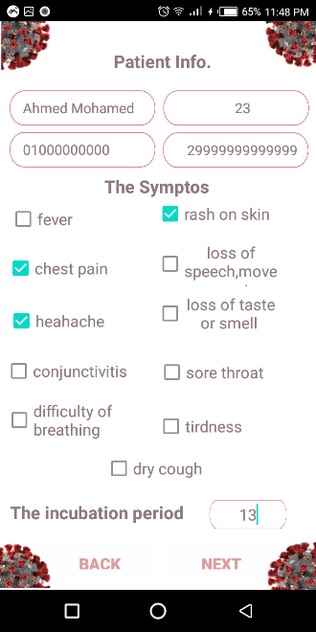activity_main :
* content:

1. Edit_Text (5)
2. Check_Box (11)
3. Button (2)
4. Label (3)
5. Image_View (4)
   * View_Result_Code_XML:

* 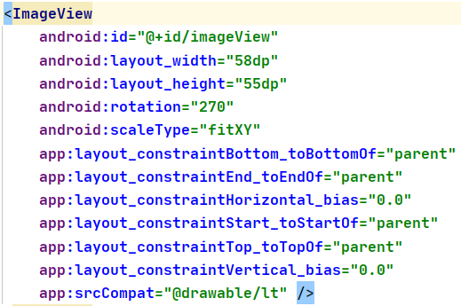insert image from @drawable in activity

* + 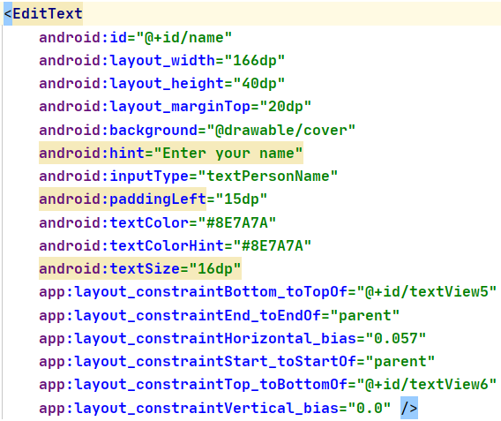Edit_Text_Code_XML:
* Pass priorities of Image_View   
  + - Back_Button_Code_Activity:

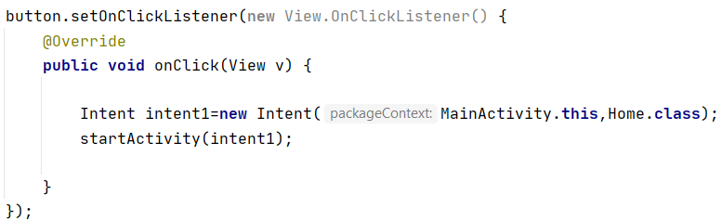

* Code of to go from activity_main to home_activity by press on Back .  
  + - Next_Code_Activity:

1. 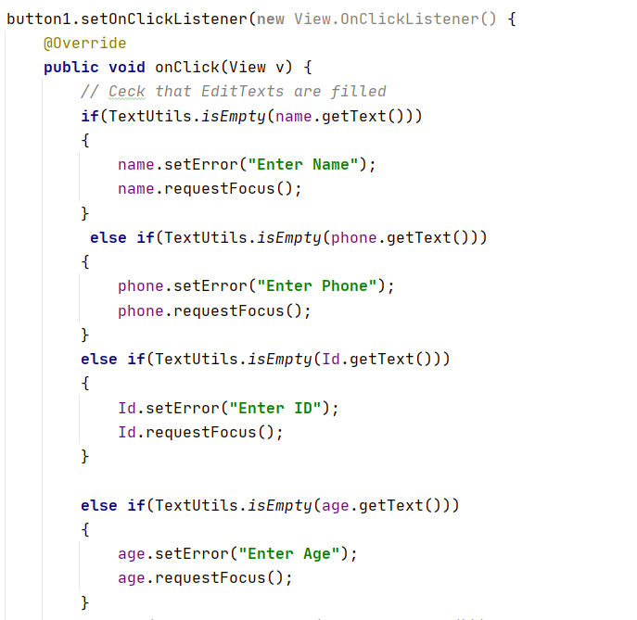Check Validation of EditTexts and CheckBox .
2. 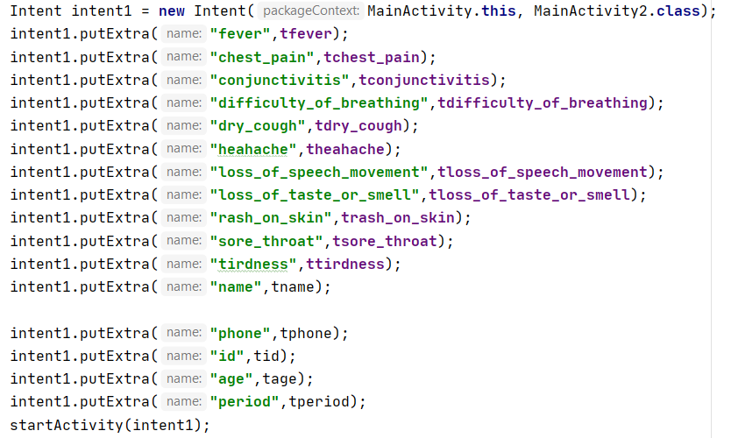Use Intent to can transform data from activity_main to activity_main_2
3. Initialize Variables for EditTexts and CheckBoxs.

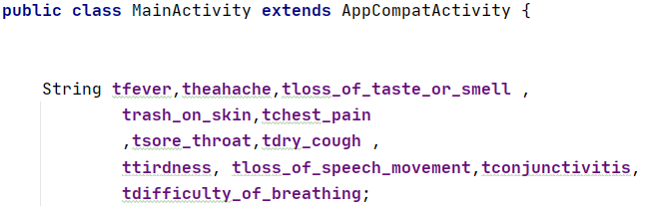

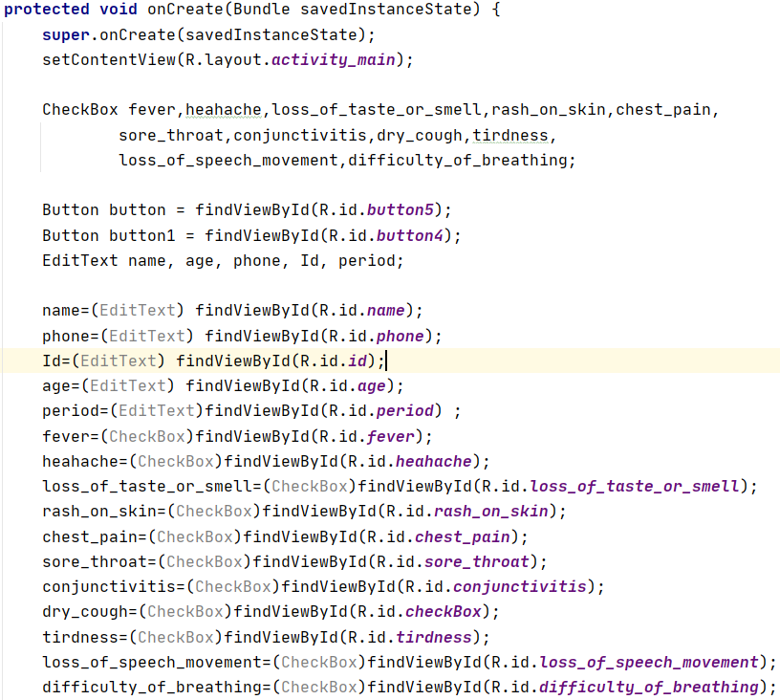

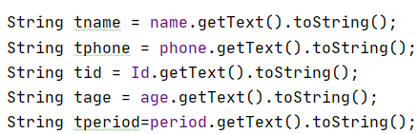

* activity_main_2 :
* content:

1. Image_View(5)
2. Label (27)
3. 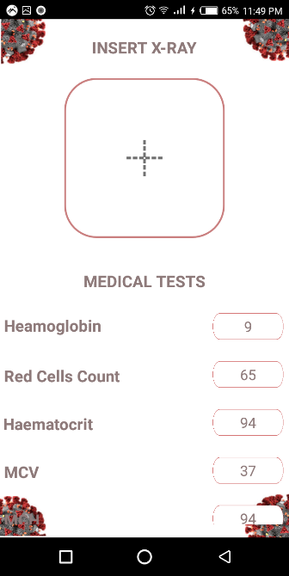Edit_Text (25)

* image_view _Code_activity_main_2:
  1. 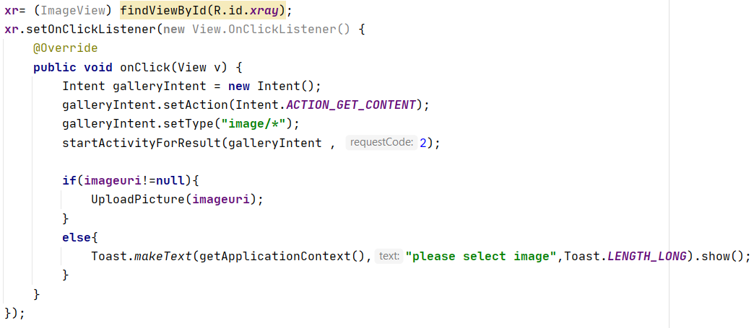Initialization :

* Edit_Texts _Code_activity_main_2 Check Fill them:

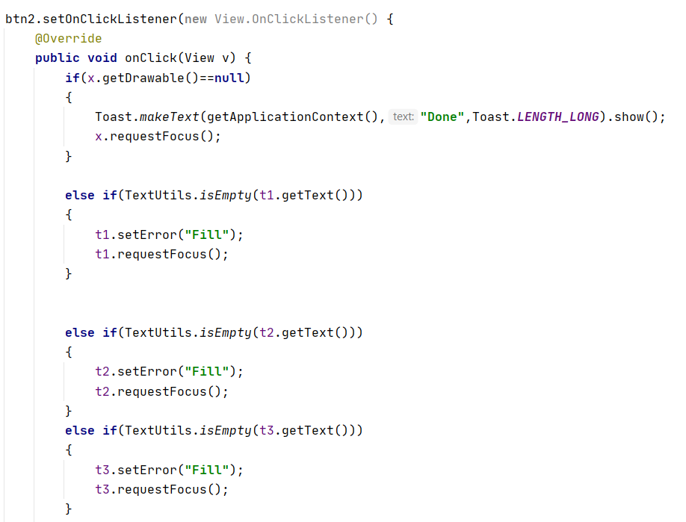

* Receive data from activity_main_2:

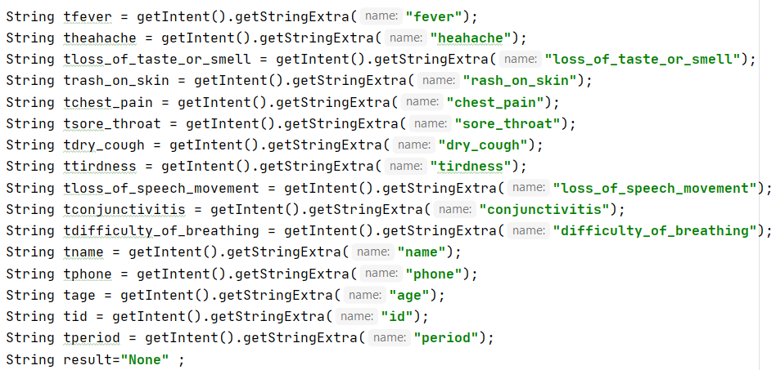

* Finish_Button :
* 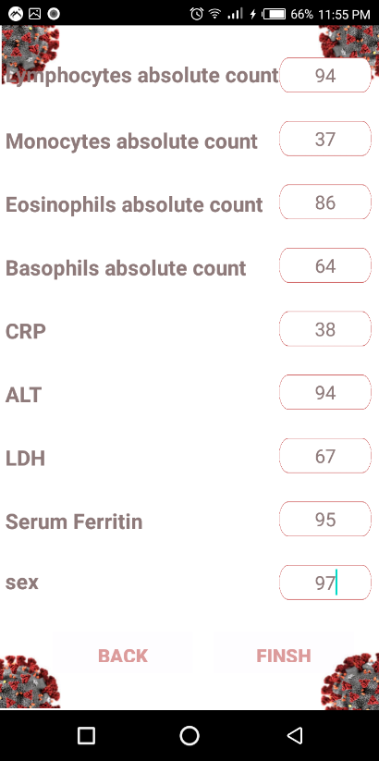Check if database Save data in firebase and exit .

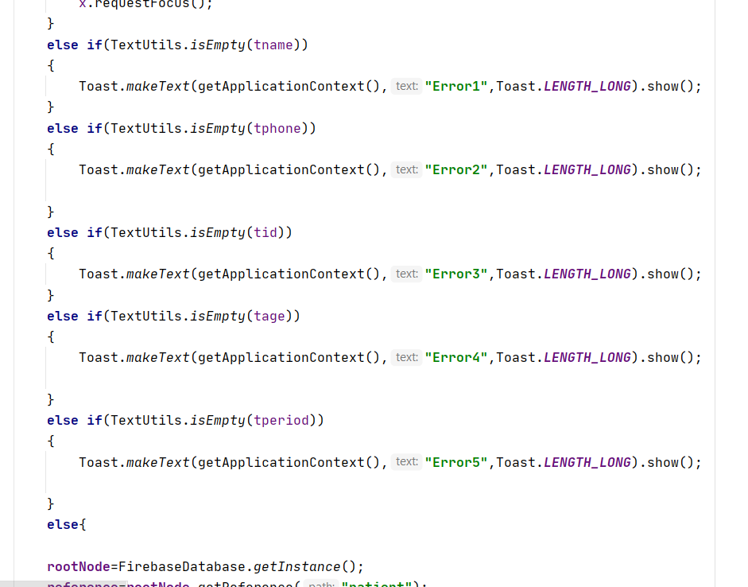

* activity_main_2 :
* 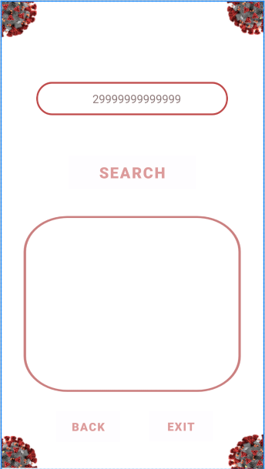contents:

1. EditText (2)
2. Button(3)

Negative!!!

* **Working on Text Model:**
* Laboratory finding Model:
* We was use SVM_Model and separate our dataset to:

1. Train dataset
2. Validation dataset

* Code:

1. 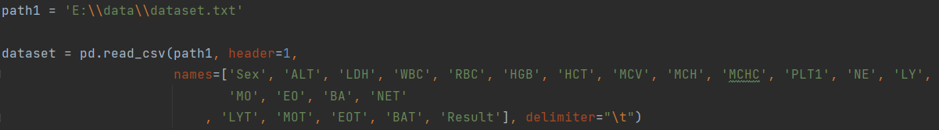Get data set from dataset file
2. 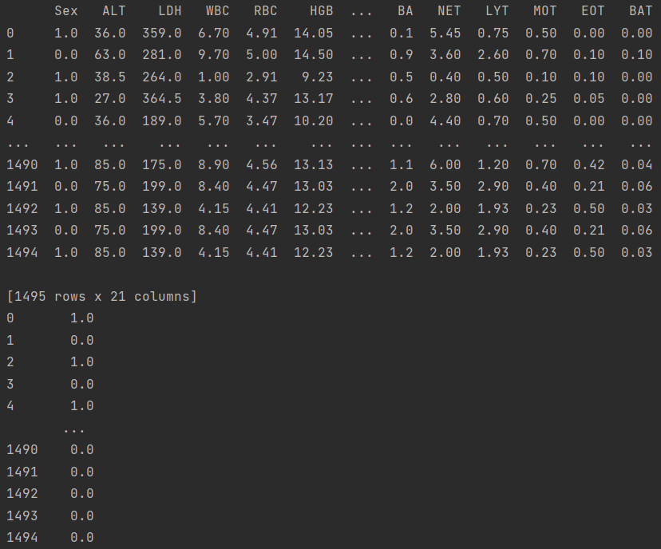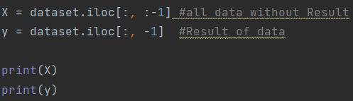Separate dataset into attributes and result and print them in console:
3. Separate data to Train with 72% and Validation 28% and do shuffle

1. Feature scaling for data

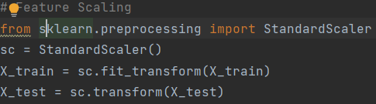

1. Create SVM_Model and pass Parameter to it then fit Dataset to it
2. Calculate accuracy of Train and Validation :

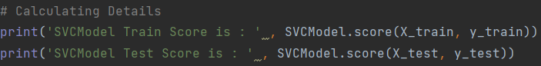

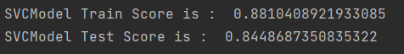

1. Calculate prediction and print it:

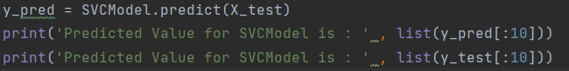



1. 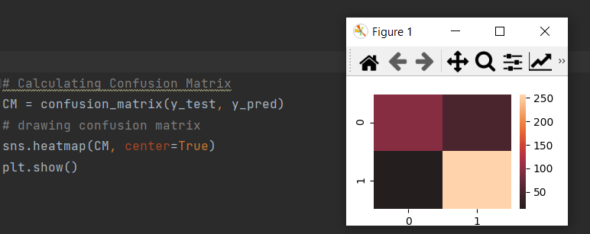Calculating Confusion Matrix and drawing confusion matrix:

* Create FireBase :
* Firebase realtime database ,store all information ,laboratory Finding and path of image (Chest x-ray) .
  + Activity_main_2:

1. Initialization some variables

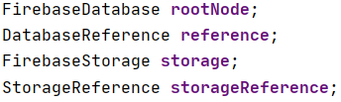

1. Create root named (Patient) and get strings that we need to upload to firebase database.

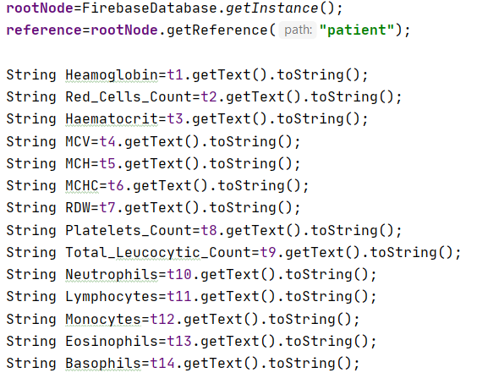

1. Set all vars that we want to store in data base depend on ordering in “patient_info” class then store these data with primary by(ID).

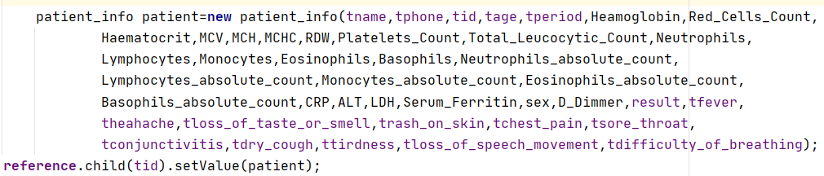

1. 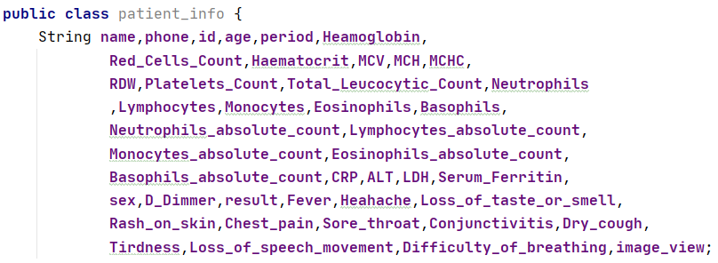Construct “patient_info” class by initialize variables with String data type and construct a constructor then construct setter and getter functions for each one

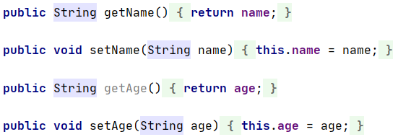

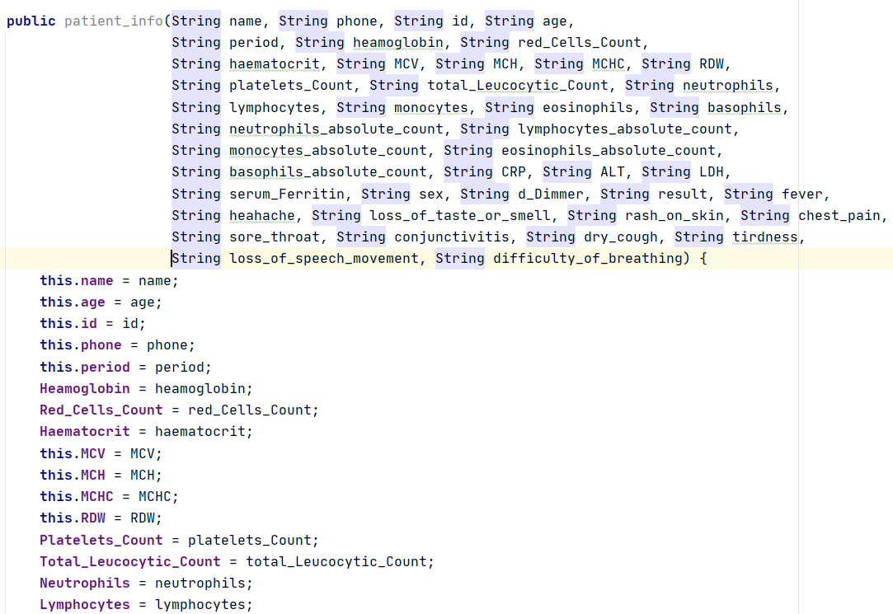

* + 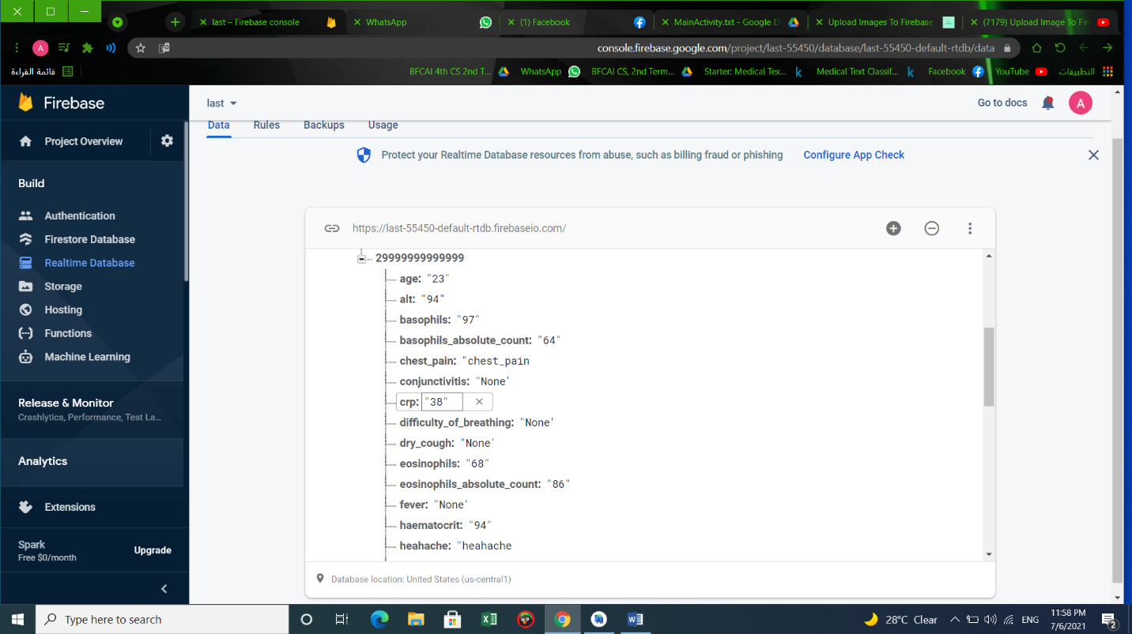data In realtime firebase with the same data in the above android App
  + 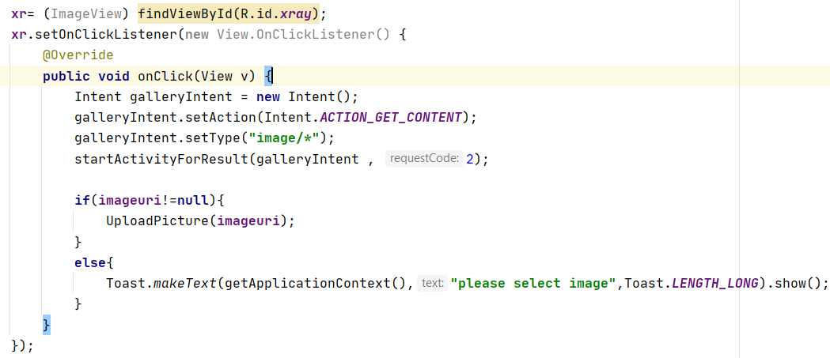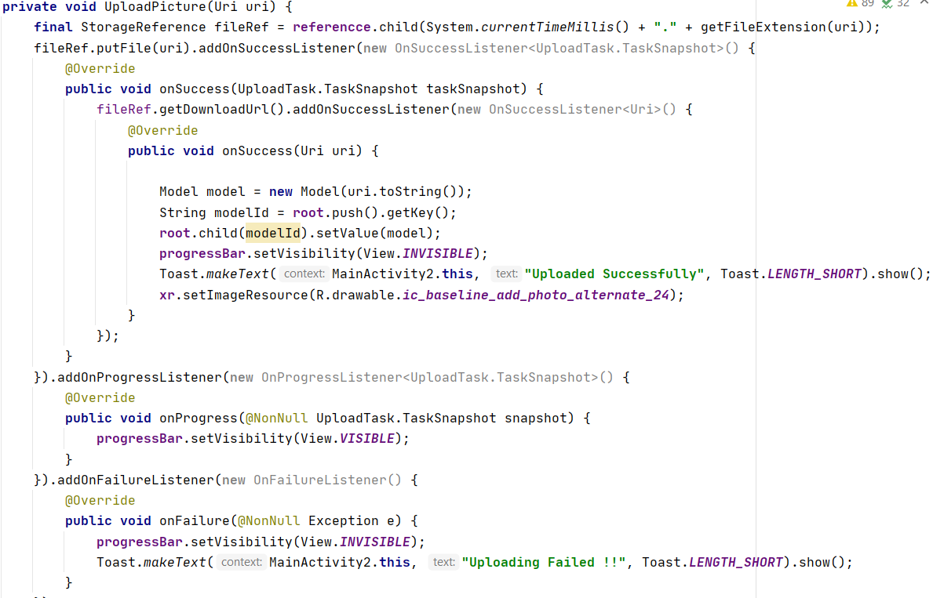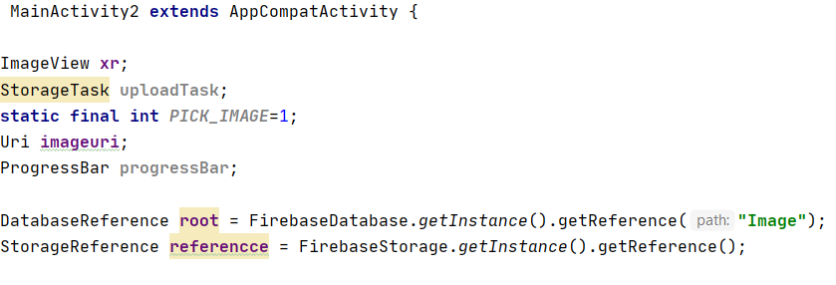Firebase Storage database Upload Chest X-Ray
* 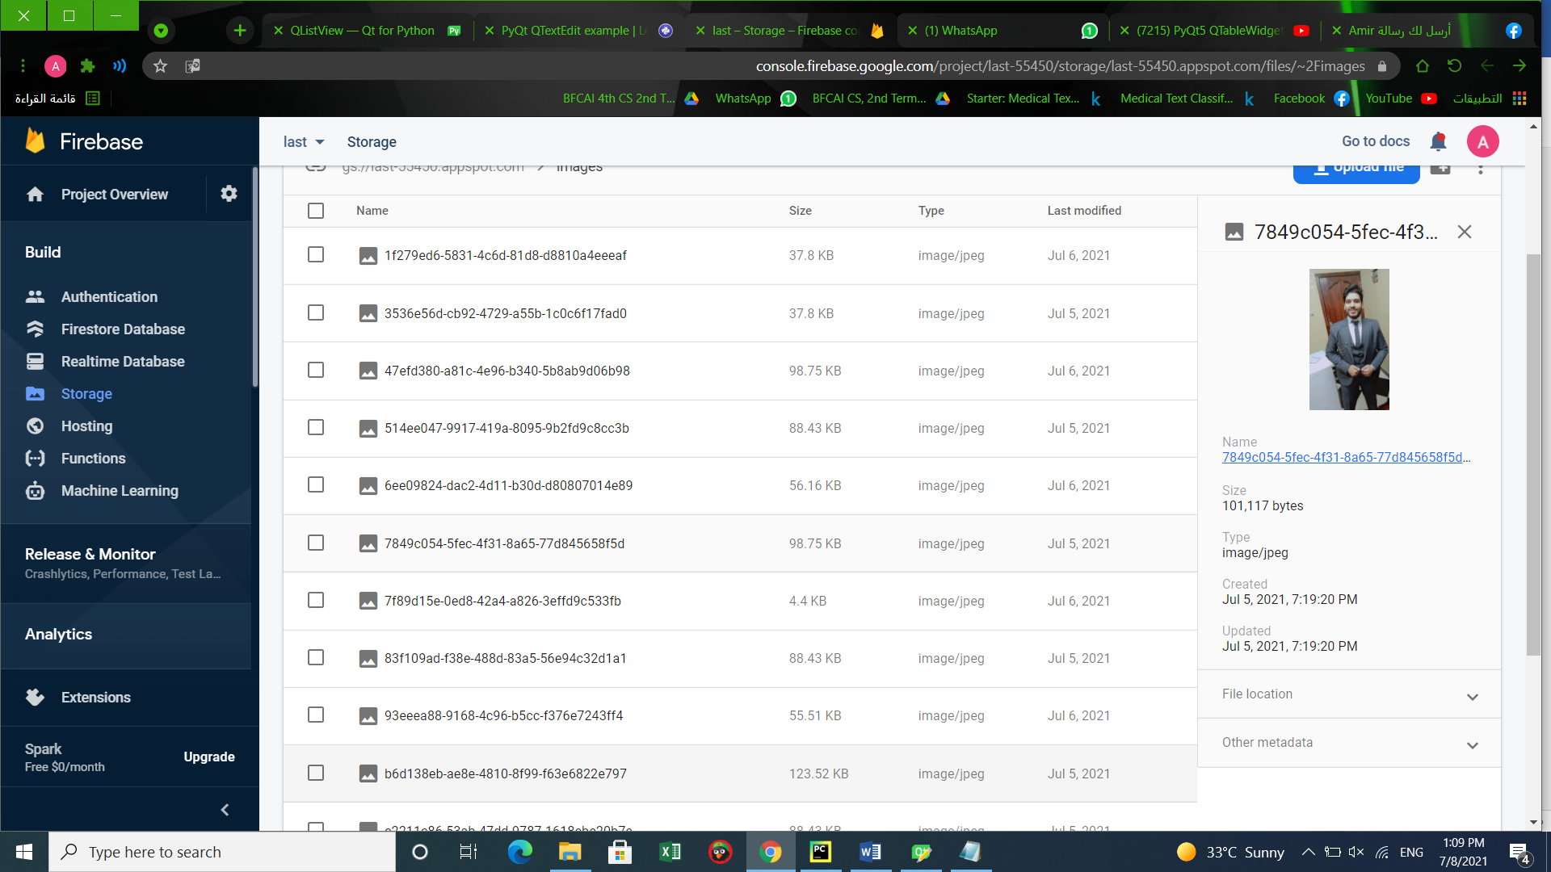Image that uploaded in Firebase Storage database.
* Connection between firebase and Models

1. Import modules

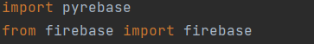

1. 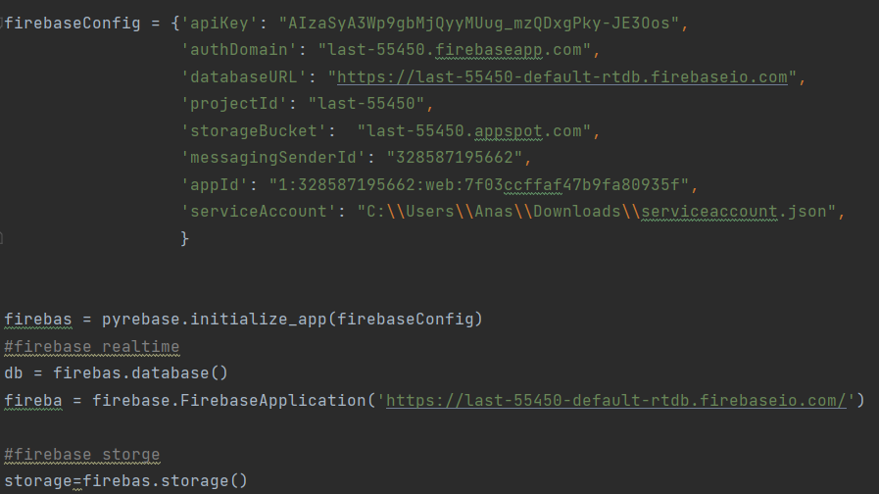Firebase Configuration :
2. 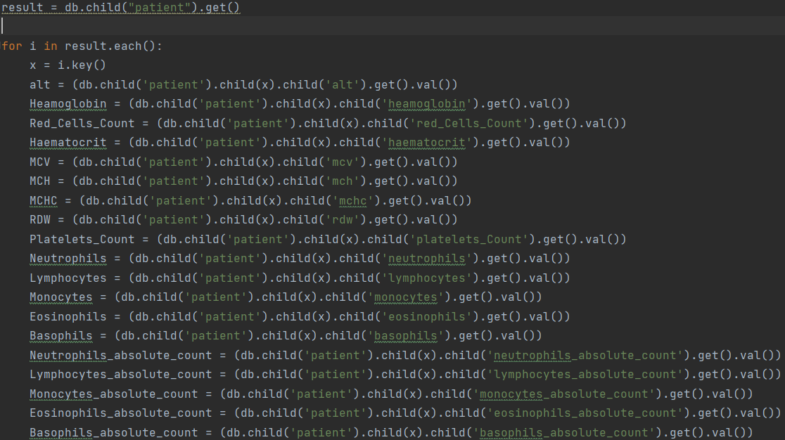Get all laboratory findings and info. from Firebase :
3. Construct 2D list of laboratory findings to process on them

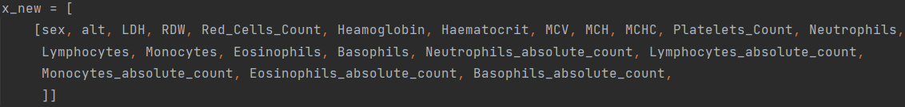

1. 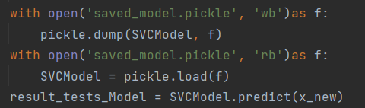Passing this list to Model to get result :
2. 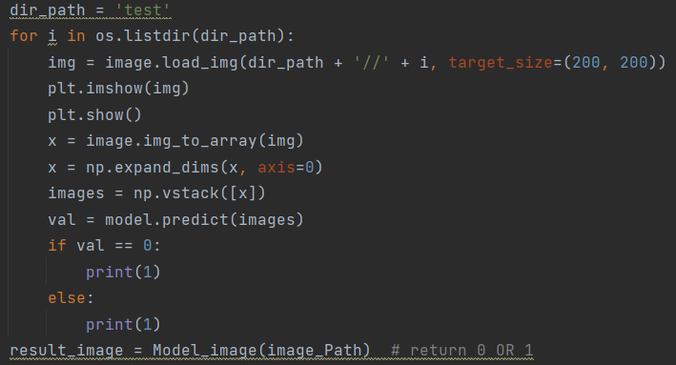Passing image to CNN Model to get result:
3. 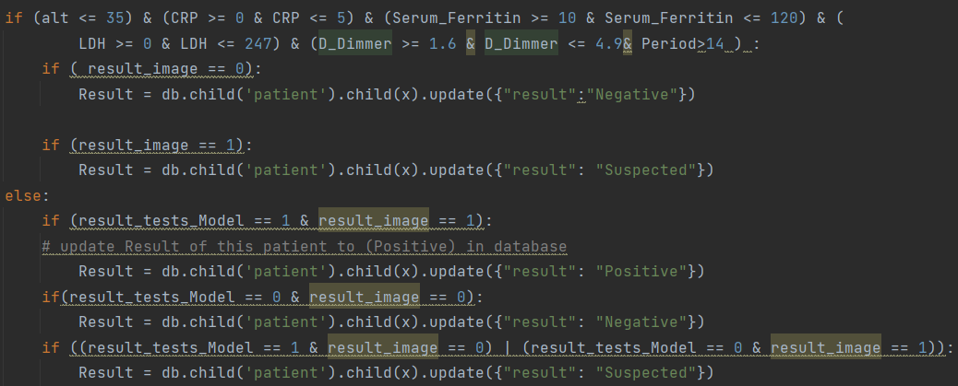Store the final Result on Firebase that depending on the compression between the result of two Models :

*Chapter 7*

# Frontend Implementation

* The disease data is uploaded by Mobile Application, which was designed by Android Studio program that uses the Java language.

1. Start activity (Home):

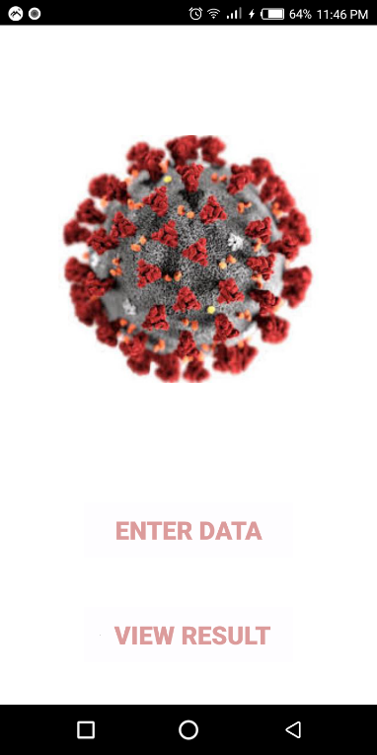

* Press Enter data to make Enter Patient data.
* Press View Result to get the result of any patient with his ID.

1. 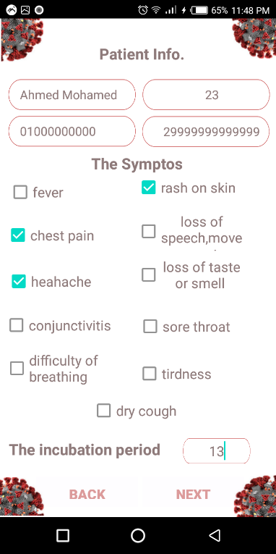Enter Data Activity:

* Patient enter his personal information (Name,phone,ID,Age).
* Enter the Symptos that he felling
* Enter the incubation period
* Press Next to go to (laboratory finding and X-Ray chest)

1. laboratory finding and X-Ray Activity :

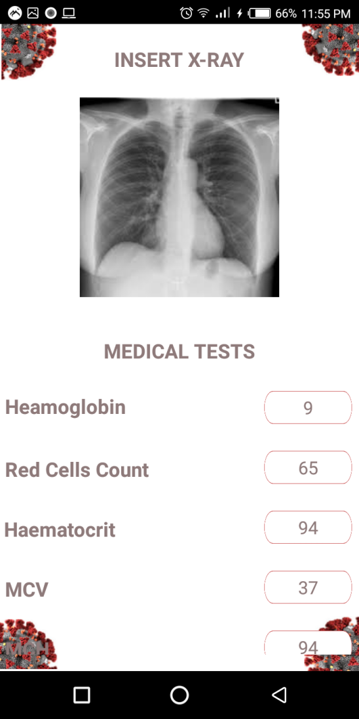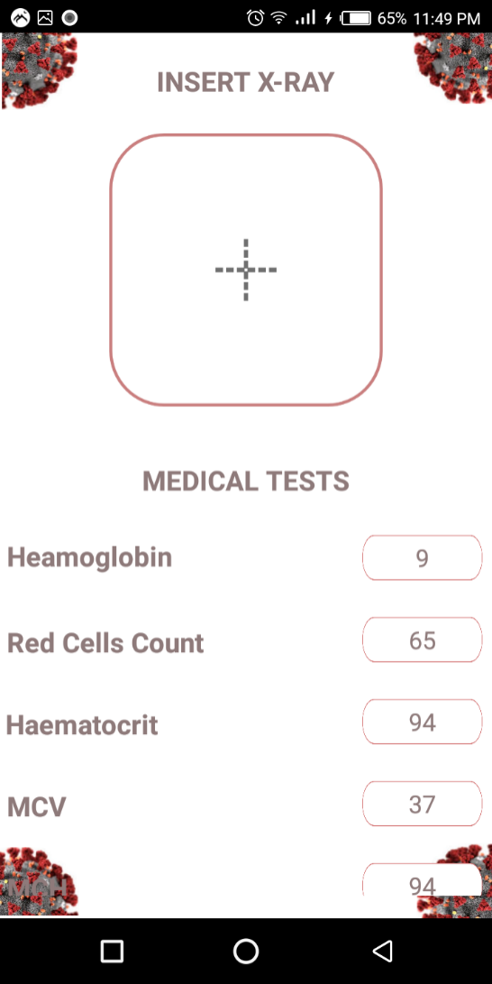

* Patient choose his chest X-RAY from your Gallery.
* Fill his laboratory findings.

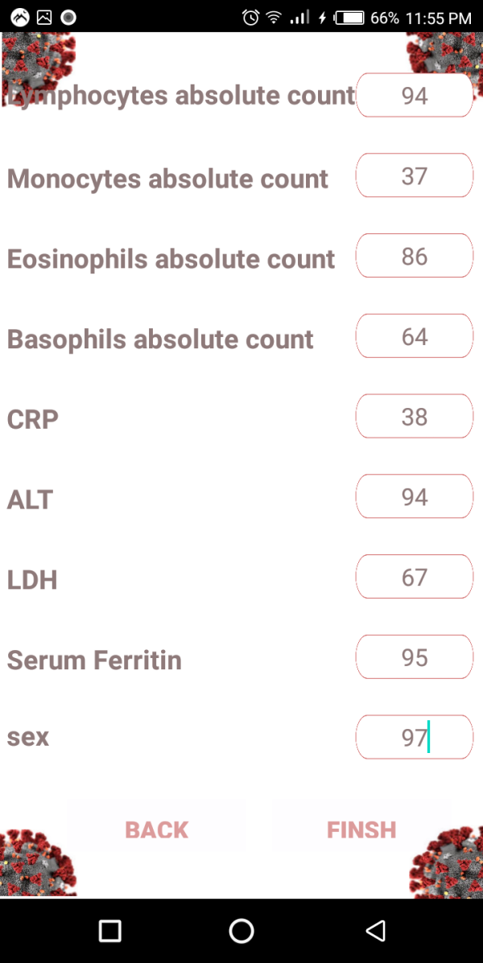

* Press Finish to upload this data in database.

Desktop Implementation:

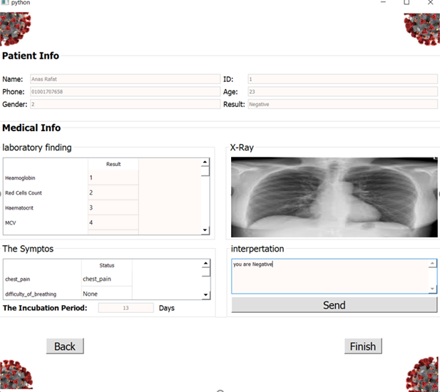

Figure 6-4 Problem & Solutions

*Chapter 8*

# PROBLEMS & SOLUTIONS

|  |  |
| --- | --- |
| Problem | Solution |
| Dataset collection, especially medical tests | The use of some government hospitals (Qaha Isolation Hospital, Benha Fever Hospital, and Benha University Hospital) and some medical laboratories, Kajal and Github sites. |
| Accuracy rate for models is Low | Many modifications to the models algorithm (epoch, correction) |
| Inability to hold enough meetings to discuss parts of the project | Conduct online meetings and use the uploading of updated files to Google drive |
| Dealing with QT app | Difficulty in dealing with QT lead to the resort of the courses and videos that interpret the work of the program and how to build a desktop app |

Table 7-1 Problem & Solutions

*Chapter 9*

# CONCLUSION:

* To reduce Covid 19, mixing between people and others must be reduced, and the project is carried out in addition to knowing the patient whether he was infected or not. The machine learning is determined whether he was infected or not, and communication between him and the doctor is done in the event that he was infected, thus reducing the mixing, time, cost and effort.
* Use some machine learning and deep learning algorithms to analyze and process data and know the patient's condition.
* In the image model, the x-rays are analyzed and the patient's condition is found if he is sick with the corona virus or not.
* In the analysis model, the analysis that is entered and the result is sent to the patient, a comparison is made between the two main models and the patient’s condition is found if he has the virus or does not have it or there are suspicions.

*Chapter 10*

# FUTURE WORK:

* A payment system for our medical system is required for the patient.
* There is a conversation between the patient and the doctor to give him the necessary advice to prevent corona virus.
* New data that is added to the program from new patients and adding the data and its results to the dataset again advice to prevent corona virus.
* The new data that is added to the program from new patients and adding the data and its results to the dataset again.

# References

Brinati, D., Campagner, A., Ferrari, D., Locatelli, M., Banfi, G., & Cabitza, F. (2020, April 25). *Detection of COVID-19 Infection from Routine Blood Exams with Machine Learning: a Feasibility Study*. Zenodo.  
 <https://zenodo.org/record/3886927#.YOTl7ejXJPY>.

Google. (n.d.). *Add Firebase to your Android project*. Google. <https://firebase.google.com/docs/android/setup>.

.

YouTube. (2020, June 28). *Python Firebase Realtime Database CRUD tutorial #1 - Create Data [Pyrebase]*. YouTube.   
<https://www.youtube.com/watch?v=8IWalfRUk1M>.

1. *Convolutional Neural Network (CNN)  :   TensorFlow Core*. TensorFlow. (n.d.). <https://www.tensorflow.org/tutorials/images/cnn>.
2. Asraf, A. (2020, July 13). *COVID19_Pneumonia_Normal_Chest_Xray_PA_Dataset*. Kaggle. <https://www.kaggle.com/amanullahasraf/covid19-pneumonia-normal-chest-xray-pa-dataset>.
3. YouTube. (2020, July 17). *PyQt5 QtDesigner Login and Signup Forms tutorial: for COMPLETE beginners*. YouTube. <https://www.youtube.com/watch?v=RL9nGmv3uSU&list=PLs3IFJPw3G9KhF7BeGOItwoKKLD8e3Dwu>.